

**Smart Fire Extinguisher**

**Graduation Project Implementation**

**Report**

A report presented by Makram Ghraizi, Rabih HusseinKiwan, and Nizar Sheyhayeb to the Department of Mechatronics, at the Issam Fares Faculty of Technology, University of Balamand.

**Advisor:** Dr. Gilbert Tekli.

June 2024.

# Acknowledgement:

We would like to thank Dr. Gilbert Tekli for his time and guidance throughout this project. Your advice and support have proven to be beneficial for our team.

Also, we would like to thank the University of Balamand for establishing a favorable learning setting and supplying the necessary resources for our project. Their unwavering support has created an environment of development and learning, significantly contributing to our academic experience.

# Abstract:

This project presents the development and implementation of an advanced Smart Water Sprinkler System designed for fire detection and extinguishing. Using and integrating artificial intelligence (AI), robotics, and high-pressure sprinkler technology, the system aims to address critical limitations in current firefighting methodologies. The AI component employs a model trained on a diverse dataset to detect fires accurately, while a precision-focused robotic arm precisely points to the source after getting the location of the fire. The high-pressure sprinkler system ensures rapid and efficient extinguishing. The system architecture, illustrated herein, outlines the seamless interaction of these components. In order to find the best approach between different fire detection methods, previous works and projects were studied to create the most suitable and cost-effective design. From there, we proposed our design for the module. The project design is separated into four parts, system, software, mechanical, and electrical. The system provides an overview on what we aim to implement. The software design includes a model, trained to detect fire in real time and return the location of the fire, and another model that aims to improve the decision of the first model. The mechanical design contains a 2 DOF robot arm with servo motors, paired up with a PI camera. The electrical design describes the connections of all the components, mainly a Raspberry Pi 3 B+ paired up with a NodeMCU32-S. We aim to test and evaluate the project in indoor environments, considering factors such as room size, range limitations, and adaptability. This project signifies a significant stride towards enhancing fire safety through the integration of cutting-edge technologies, with potential applications in residential and industrial settings. The project also includes an IOT solution aimed for seamless manual and automatic mode switching.

To achieve that we integrated the esp32 nodeMCU32-S module and created custom serial communication between the two devices (Raspberry Pi and NodeMCU32-S).

# Table of Contents

Acknowledgement: 2

Abstract: 3

Table of Contents 4

List of Figures 6

List of Tables 8

I. Introduction: 9

II. Preliminaries: 10

1. Machine Learning model: 10

2. CNN: 10

3. Metrics: 11

a) Precision: 11

b) Recall (Sensitivity): 11

c) F1 Score: 11

d) Accuracy: 11

III. Related Works: 12

IV. Our Approach: 15

1. System Design: 15

2. Software Design: 16

3. Mechanical Design: 20

4. Electrical Design: 22

V. Risk Assessment: 23

VI. Testing and Implementation: 24

1. Components and Costs: 24

2. Testing: 25

a. YOLOv5: 25

b. Coordinates: 31

c. Serial Communication between Raspberry Pi and NodeMCU32-S: 32

d. Sensor implementation: 35

e. Manual/AUTO: 38

f. Broadcast: 40

g. NodeMCU: 41

h. Run On Startup: 45

i. Random Forest Trees Model: 45

j. YoloV5 with Random Forest Trees: 48

3. Assembling the System: 50

a. Assembling the arm: 50

b. Electronic Setup: 50

c. Camera Arm Connection: 51

d. Case Setup: 51

e. Full Assembly: 52

VII. Conclusion and Future Work: 53

References: 55

Appendices: 57

Appendix A: Additional Literature Review 57

Appendix B: Fire Detection Methods: 59

Appendix C: Components: 61

Appendix D: Codes: 64

1. Smoke Senor Testing: 64

2. Thermal Imager Code: 65

3. Heatmap code using python: 66

4. YoloV5 Detect.py on Raspberry Pi: 66

5. Coordinates: 73

6. Run on Start: 76

7. Broadcast CamToWeB: 76

8. NodeMCU32-S Initialization Code: 77

9. Forest Trees Dataset: 88

10. Forest Trees Model: 88

Appendix E: YoloV5 Testing: 89

# List of Figures

Figure 1 - CNN example https://www.analyticsvidhya.com/blog/2021/05/convolutional-neural-networks-cnn/. 10

Figure 2 - Suggested System Flowchart 15

Figure 3- System Model on Inventor 2020 16

Figure 4-Training and Validation 18

Figure 5- Decision trees-https://www.ibm.com/topics/decision-trees. 19

Figure 6- Decision Trees example. 19

Figure 7- Forest Trees - https://www.analyticsvidhya.com/blog/2020/05/decision-tree-vs-random-forest-algorithm/. 20

Figure 8 - Roll Pich Yaw 21

Figure 9-Robotic Arm Design 22

Figure 10- Partial Electric Design 23

Figure 11- Running YOLOv5 on Personal Laptop with GTX1660Ti 25

Figure 12 - Results on laptop. 26

Figure 13 - Response time on RPi using TFLite. 27

Figure 14 – Confidence. 27

Figure 15- Precision Recall 28

Figure 16 - Recall Confidence 28

Figure 17 - Precision-Confidence 29

Figure 18- Confusion Matrix 29

Figure 19 -Importing. 30

Figure 20- Angles. 30

Figure 21 -sweep. 30

Figure 22 Constants. 31

Figure 23 Move Servo Function 31

Figure 24 Code Snippet 32

Figure 25 Code Snippet that sends servo and sensor values. 33

Figure 26 Serial Connection 34

Figure 27 - read from node MCU. 34

Figure 28-Smoke sensor setup. 35

Figure 29- results. 35

Figure 30- Results on Smoke 36

Figure 31 - Array from AMG8833 36

Figure 32- Code snippet. 37

Figure 33- Heatmap Code 37

Figure 34- Heatmap. 38

Figure 35 code snippet automatic Mode. 38

Figure 36 code snippet mode switching form. 38

Figure 37 code snippet is function for auto/manual switching. 39

Figure 38 code snippet form + js function. 39

Figure 39 backend function auto/manual. 39

Figure 40 code snippet backend handling. 40

Figure 41- Broadcast. 40

Figure 42 code snippet Initialization start. 41

Figure 43 code snippet read initialization flag. 42

Figure 44 code snippet reset button. 42

Figure 45 code snippet AP function. 43

Figure 46 - connecting to WIFI. 44

Figure 47 - Saving Credentials 44

Figure 48 - Bash startup script. 45

Figure 49 - Fire Dataset 46

Figure 50- MODEL. 46

Figure 51 - Metrics. 47

Figure 52 - Predict Script 47

Figure 53 - Prediction result. 47

Figure 54 - Forest Trees implementation on Project. 48

Figure 55- NoFire. 49

Figure 56 – Fire. 49

Figure 57 - arm Assembly. 50

Figure 58 - electronic setup. 51

Figure 59 - Camera setup. 51

Figure 60 - drilling for the arm. 52

Figure 61 - Case. 52

Figure 62 - Outdoor Testing 53

Figure 63-Different techniques of image processing. 59

Figure 64 - Water pump. 62

Figure 65- AMG8833- https://www.amazon.com/DEVMO-AMG8833-Temperature-Compatible-Rasp-Berry/dp/B09L4QP91N 63

Figure 66- ESP32-NodeMCU-32S- \https://www.ubuy.com.lb/en/productcn/IEN3XPJLC-nodemcu-esp-32s-esp-wroom-32e-wifi-development-board-service-port-wifi-bluetooth-module- 64

Figure 67 - Arduino relay module-https://katranji.com/en/item/365048. 64

Figure 68-Smoke Sensor Testing on ESP32. 65

Figure 69- Thermal imager code. 65

Figure 70 - heatmap code. 66

Figure 71 - detecy.py pt1. 67

Figure 72- detect.py pt2 68

Figure 73- detect.py pt3. 69

Figure 74 - detet.py pt4 70

Figure 75- detect.py pt5. 71

Figure 76 - detect.py pt 6. 72

Figure 77 - SAtoAngles.py pt1. 73

Figure 78- - SAtoAngles.py pt2. 74

Figure 79 - SAtoAngles.py pt3. 75

Figure 80 - Run model when RPI starts. 76

Figure 81 - Broadcast Cam to Webpage. 76

Figure 82- Forest Trees Dataset 88

Figure 83- Model 2 88

# List of Tables

Table 1 - Information from some of the articles reviewed. 13

Table 2- Cross Referencing Fire detection methods 17

Table 3-Cross referencing Criteria for Robot Arm 21

Table 4-example of a DH parameter table 21

Table 5- Risk Assessment 24

Table 6- Components and Prices 24

# Introduction:

Fires, wherever they may occur, pose a big threat to human lives, properties, and the environment. With the technological advancement the world is seeing, the methods of fire extinguishing and suppression have come a long way. From the traditional shovel to put out a fire, to handheld fire extinguishers containing dry ice or to wall mounted water sprinklers. Traditional wall-mounted fire extinguishers, while effective to some extent, often fall short in scenarios with complex environments, uneven fire distribution, or large spaces, such as industrial facilities, warehouses, and research laboratories. But now, modern technology offers more innovative solutions for fire prevention and control. Our proposal centers on the development of a Smart Water Sprinkler System—a novel approach that combines state-of-the-art AI-based fire detection, a precisely engineered 2-degree-of-freedom (2-DOF) robotic arm, and a high-pressure water sprinkler. This project aims to revolutionize fire safety, offering advanced capabilities that extend beyond conventional fire suppression systems. It also gives the user the ability to remotely watch or control the process.

The problem we aim to address with our Smart Water Sprinkler System is the need for a more precise, efficient, and adaptable approach to fire suppression. Traditional wall-mounted fire extinguishers disperse extinguishing agents indiscriminately, which can lead to excessive resource usage, collateral damage, and, in some cases, inadequate fire control. Furthermore, they may not effectively address fire incidents in big spaces, where identifying the precise location of the fire is challenging. Our proposed system intends to revolutionize firefighting by introducing a targeted approach that overcomes these limitations. By incorporating artificial intelligence for fire detection and a robotic arm capable of pinpointing the fire's exact location, our Smart Water Sprinkler System ensures that the extinguishing agent is deployed precisely where needed, thereby conserving resources and reducing the risk of fire re-ignition.

This project aims to redefine fire safety by offering a solution that is adaptable to diverse environments and fire scenarios. By addressing the limitations of traditional fire extinguishing methods, our Smart Water Sprinkler System holds the promise of mitigating fire-related risks and safeguarding lives and property more effectively.

Our main objectives in this project are:

1. Develop an AI-Based Fire Detection System: Create a robust AI-driven fire detection system that can accurately identify fire incidents in real-time, providing precise location information, with of course the help of sensors and a camera for real time detection.
2. Design and implement a 2-DOF Robotic Arm: Implement a 2-degree-of-freedom (2-DOF) robotic arm equipped with the capability to autonomously point to the detected fire source using servo motors.
3. Integrate AI Fire Detection with Robotic Arm Control: Seamlessly integrate the AI-based fire detection system with the robotic arm control mechanism to facilitate a swift and precise response to fire incidents.
4. Implement a High-Pressure Water Sprinkler System: Develop and deploy a high-pressure water sprinkler system that can be activated upon fire detection to extinguish fires efficiently.
5. Create an IOT monitor and control solution by utilizing the NodeMCU32-S. The solution will feature an initialization to the network webpage and a monitor and control webpage.

By achieving these objectives, our project aims to provide an advanced fire prevention and control system that surpasses the limitations of traditional fire extinguishing methods and significantly enhances the efficiency, precision, and adaptability of firefighting efforts.

When designing Smart Water Sprinkler System, several risks have been identified with aspects ranging from the reliability of the fire detection system to the mechanical and electrical components' functionality.

# Preliminaries:

## Machine Learning model:

A Machine Learning (ML) model is a computational artifact that learns patterns from data to make predictions or decisions without being explicitly programmed. It is a powerful tool for making predictions or decisions based on data. It involves selecting the right type of model, training it on a dataset, and evaluating its performance using appropriate metrics.

## CNN:

Convolutional Neural Networks (CNNs) are a class of deep learning models specifically designed for processing and analyzing visual data. They are particularly effective for image recognition and classification tasks due to their ability to learn spatial hierarchies of features automatically and adaptively from input images as seen in Figure 1.

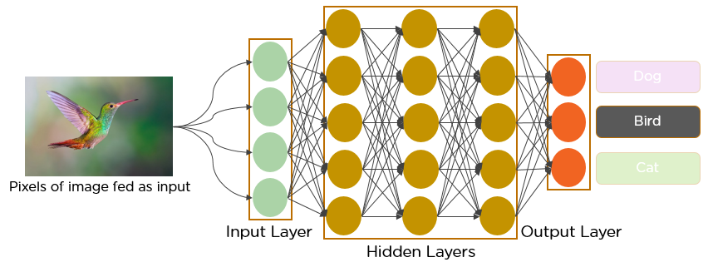

Figure 1 - CNN example https://www.analyticsvidhya.com/blog/2021/05/convolutional-neural-networks-cnn/.

## Metrics:

### Precision:

Precision is the ratio of correctly predicted positive observations to the total predicted positives. It assesses the accuracy of the positive predictions.

Precision=True Positives / False Positives + True Positives​

### Recall (Sensitivity):

Recall, also known as sensitivity or true positive rate, measures the ability of the model to capture all the relevant instances of the positive class.

Recall=True Positives /True Positives + False Negatives

### F1 Score:

The F1 score is the harmonic mean of precision and recall. It provides a balance between precision and recall. The F1 score is particularly useful when there is an uneven class distribution.

F1=2× (Precision × Recall)/ (Precision + Recall)

### Accuracy:

Accuracy is the ratio of correctly predicted observations to the total observations. It provides a general measure of the model's correctness.

Accuracy= (True Positives + True Negative) / (True Positives + True negative + False Positives + False Negative)

These equations use the terms:

True Positives (TP): Instances where the model correctly predicts the positive class.

False Positives (FP): Instances where the model predicts the positive class, but it's incorrect.

False Negatives (FN): Instances where the model fails to predict the positive class.

True Negatives (TN): Instances where the model correctly predicts the negative class.

# Related Works:

Fire incidents pose a significant threat to life, property, and the environment, necessitating efficient fire detection and rapid response systems. Traditional methods often lead to delayed responses and increased risks, highlighting the urgency for innovative solutions. This literature review delves into the integration of artificial intelligence (AI) into fire detection systems within a comprehensive smart sprinkler project, aiming to revolutionize fire prevention and control.

Kakde et al. (2018) introduced a real-time fire detection model based on artificial intelligence techniques. Their model relies on color-based detection, a methodology demonstrating promising results in quickly identifying fire incidents. Furthermore, they implemented the Bitwise AND operation for masking purposes, enhancing the precision of fire detection. The inclusion of edge detection in their approach proves vital for recognizing rapid changes in objects, a crucial factor in timely fire detection. Nainar et al. (2022) adopted a similar approach utilizing image processing for fire detection. Their methodology involved morphological transformations using OpenCV, contributing to object detection in video/image feeds. The conversion of images to RGB, along with the Bitwise AND operation, underscored the significance of these techniques in real-time fire detection. Nainar et al. also recognized the importance of addressing false alarms, a common issue in fire detection systems. Al-Ghadani and Jayakumari (2020) contributed by integrating deep learning, specifically convolutional neural networks with TensorFlow and Keras, to enhance fire detection accuracy. Their method, while powerful, requires substantial training using pre-saved data or recurrent neural networks (Al-Ghadani & Jayakumari, 2020). The study emphasized the significance of machine learning, particularly in addressing challenges such as distinguishing between extreme sunlight and fire. The use of TensorFlow, Keras, and OpenCV showcased the reliability of these tools in image processing for fire detection.

A study on a two-degree-of-freedom (2-DOF) robotic arm, exploring modeling, simulation, and control aspects was conducted by Ghaleb and Ali (2018). The integration of Denavit-Hartenberg parameters for forward kinematics and Euler-Lagrange equations for dynamics enhances the efficiency of the robot arm (Ghaleb & Ali, 2018). The study incorporates a proportional-integral-derivative (PID) control system for better control, demonstrating reduced settling time, overshoot, and steady-state error, highlighting the practical significance in manufacturing and hazardous task environments (Ghaleb & Ali, 2018).

Sekarsari et al. (2019) presented a 2-DOF robotic arm controlled by an Arduino Uno microcontroller with an ultrasonic sensor for object detection. The design emulates the human arm, featuring a gripper and demonstrating capabilities for lifting and moving light objects. The paper provides detailed insights into mechanical design, kinematics, and system flow, emphasizing the importance of kinematic control for achieving desired positions (Sekarsari et al., 2019). Their work included a detailed exploration of mechanical design, servo motor installation, and the integration of an ultrasonic sensor for object detection.

Dr. B. Therese introduced a novel approach by integrating real-time image processing using a Raspberry Pi with a 7-DOF robotic arm. The system detects and sorts objects based on color, offering both manual and automated control. The research underscores its application in industrial settings for precise object segregation (Therese, 2018).

The development and testing of an autonomous fire suppression system involve the integration of multispectral sensors, UV detectors, and IR stereovision for fire detection and targeting. A deterministic trajectory algorithm adjusts the nozzle angle for effective suppressant application (McNeil et al., 2013). The system utilizes UV sensors for rapid fire detection, vision systems for locating and suppressing fires, and a trajectory model based on water droplet physics to predict optimal spray angles (McNeil et al., 2013). The UV sensor triggers the fire identification algorithm, with IR and visual cameras used for fire identification and stereovision for precise localization of the fire base (McNeil et al., 2013).

Michael J. Gollner's editorial emphasizes the pivotal role of early fire detection and suppression technologies. Advances such as video fire detection, nuisance alarm reduction, and autonomous fire suppression on robotic platforms are explored. Challenges related to false alarms are addressed, introducing innovative solutions and technologies, including water mist systems (Gollner, 2016).

Another paper presents a study on an autonomous fire suppression system designed for close-range, localized fire suppression tasks employed visual servoing for nozzle positioning. The paper discussed the integration of a probabilistic water classification method, stereo processing, and a Golden Section Search for optimal spray positioning. The application of Kalman filtering for angle measurements and a decision tree for nozzle positioning modes showcased the system's potential for autonomous fire suppression in various conditions (McNeil & Lattimer, 2016).

Table 1 - Information from some of the articles reviewed.

|  |  |  |  |
| --- | --- | --- | --- |
| Articles | Sensors/Algorithms | Summary | Results |
| Robotic Fire Suppression Through Autonomous Feedback Control | 2 Infrared Sensors  1 long wavelength IR)  1 Ultraviolet Sensor  1 visual camera  Real Time feedback of fire size and spray direction  probabilistic water classification method  disparity map generated from the IR stereovision system to calculate a 3D coordinate position | Leverage the capabilities of two infrared (IR) cameras to effectively detect and localize fires. The initial positioning of the nozzle is determined using the fire coordinates obtained from the IR stereovision system, combined with a predictive spray trajectory model. This approach allows for accurate and efficient targeting of the fire for suppression. The system has been extensively tested in various operational scenarios, including indoor and outdoor environments. | suppression times ranging from 8.1 seconds to 27.9 seconds, with a mean of 16.9 s |
| Autonomous Fire Suppression System for Use in High and Low Visibility Environments by Visual Servoing | IR FLIR A35 IR sensors  Robotis Dynamixel MX-106T motors  Hamamatsu UVTron sensor | The system employs UV and IR sensors for fire detection, while a stereo vision system provides 3D coordinates of the fire. Once the fire is located, the system autonomously directs a water spray to suppress the fire, adjusting the nozzle position as needed. The algorithm also incorporates feedback control to determine when to stop the agent application. This approach showcases the potential for autonomous fire suppression in challenging indoor environments, offering a promising solution for enhancing firefighting capabilities. | Results from tests demonstrate the system's effectiveness in both clear and low visibility environments, with the system successfully suppressing a wood crib fire in an average time of 4.80 seconds under low visibility conditions. |
| Autonomous Fire Suppression Using Multispectral Sensors | Hamamatsu UV-Tron sensor.  CCD camera  2 Infrared Sensors FLIR Tau324  YCbCr color space  hierarchical Bayesian Networks | The system includes UV sensors, stereo infrared (IR) vision, and a deterministic trajectory algorithm to detect and target fires for suppression. The paper discusses the use of UV sensors for early fire detection, the application of stereo vision systems to locate and suppress fires, and the effectiveness of infrared cameras in identifying fires through low visibility conditions. The paper details the selection and testing of UV sensors, color-based fire identification methods using visual image data, and the use of IR stereo vision systems for locating fires in low visibility conditions. The paper describes the physics model used to predict the spray trajectory, the calibration and testing of the autonomous suppression system, and the results from actual fire suppression tests. | fully suppressed using the system in less than 30 seconds. |

In the above table, we have extracted some important information on the sensors and technologies used for the designed projects respectively. See appendix A for a more detailed review.

# Our Approach:

For the design of our project, we have four main parts. The fire detection and localization module using the Raspberry Pi, the 2 DOF robotic arm, the NodeMCU32-S for motor movement and remote control, and the high-pressure water sprinkler, all infused together for the success of the prototype.

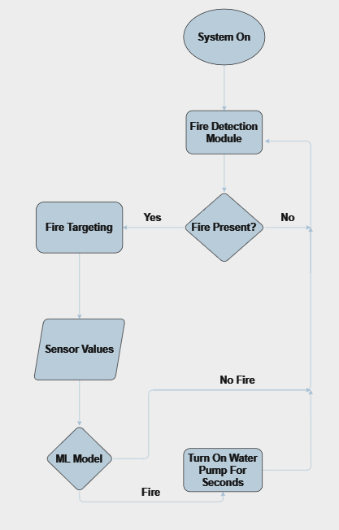

Figure 2 - Suggested System Flowchart

As seen in Figure 2, we start by turning on the system and then sweeping for detection. Then the flame detection module is activated if a flame is present, we go towards fire targeting and then we get additional sensor values. We then implement another machine learning algorithm if the machine learning algorithm detects that there is a fire present, we turn on the water pump for a couple of seconds if not we'll go back to the flame detection module.

## System Design:

Our system aims to change how traditional firefighting happens. We are creating a full system that is able to monitor the whole room, detect, extinguish, and check again for fires. We have A raspberry pi camera mounted on the servo motor that moves in the x-direction, that keeps swiveling in 5 degree increments to monitor the whole room. Attached beside it is a thermal imager that proves that what the camera sees is actually fire and not just an image or a reflection of a fire. The camera is connected to the RPI that has YOLOv5 running on it, and the servo motors are connected to the NodeMCU32-S that takes coordinates from the RPi via a serial connection. Getting the coordinates mainly requires the image length and width, and the exact position and dimensions on the bounding box drawn on the fire. Then, calculations are made to precisely direct the motors towards the bounding box.

For budget reasons, we chose to build our system in an 80x80x40 cm enclosure as seen in Figure 3 to resemble a room. We have attached a fuel pump to spray water to the robotic arm. Here below is the CAD assembly of our system.

.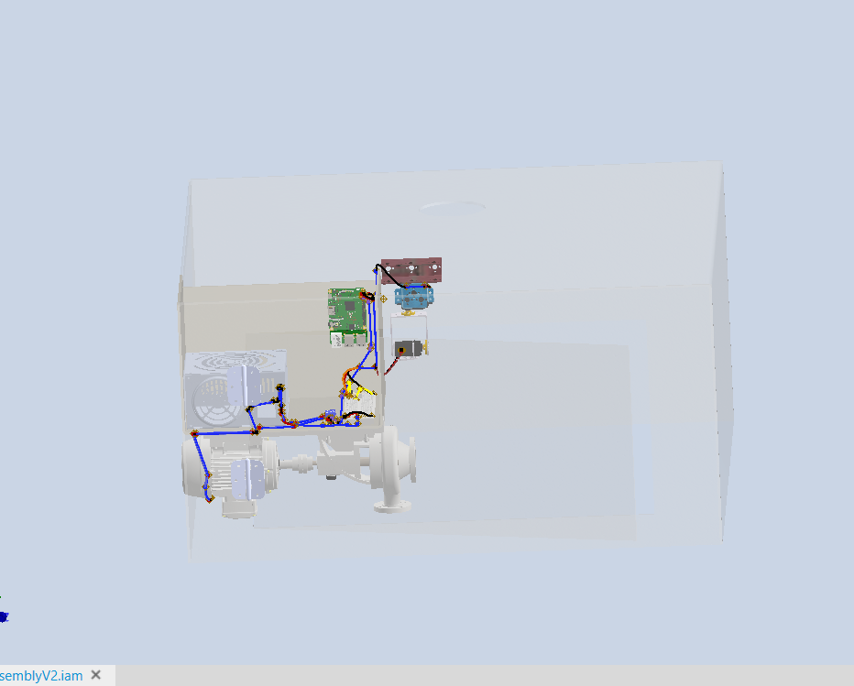

Figure 3- System Model on Inventor 2020

We aim to use computer power supply to power up all the devices we are working with at different voltages, and place all the electrical components in a mini Plexi enclosure to prevent fire or water from reaching it.

## Software Design:

The software design is mainly made of the fire detection and localization module. It should be able to detect a fire and give its precise location in space. There are several approaches to detect fire in real time, from image processing, WSN’s, and machine learning. See appendix B for detailed information. So, to detect fire we have to achieve the properties of the solution we mentioned above which are detection of heat, detection of smoke, detection of flame, calculating the location of the fire, fast response time, and IoT capabilities.

To ensure all these properties are possible to achieve, related works were reviewed to check if these properties were integrated in their works. From the reviewed articles, we were able to cross reference their methods with the properties of our solution to see which covers which in terms of properties as seen in Table 2.

Table 2- Cross Referencing Fire detection methods

|  |  |  |  |  |  |  |  |  |  |
| --- | --- | --- | --- | --- | --- | --- | --- | --- | --- |
| Method | Computer Vision-Based Early Fire Detection Using Machine Learning | Real-Time Early Indoor Fire Detection and Localization on  Embedded Platforms with Fully Convolutional One-Stage  Object Detection | IoT Based Automatic Forest Fire Detection Based on Machine Learning Approach | Fire Detection System Using Artificial Intelligence Techniques | Enhancing Fire Detection Technology: A UV-Based System Utilizing Fourier Spectrum Analysis for Reliable and Accurate Fire Detection | Robotic Fire Suppression Through Autonomous Feedback Control | Autonomous Fire Suppression System for Use in High and Low Visibility Environments by Visual Servoing | Autonomous Fire Suppression Using Multispectral Sensors | Required |
| Heat detection | NO | NO | YES | NO | NO | YES | YES | YES | YES |
| Smoke Detection | NO | NO | YES | NO | NO | NO | NO | NO | YES |
| Flame Detection | YES | YES | Light intensity | YES | YES, (UV sensor) | YES | YES | YES | YES |
| Flame Localization | Only in 2D space | YES, 3D SPACE | Not precise | ONLY IN 2D SPACE | NO | YES 3D | YES 3D | YES 3D | YES |
| Fast response Time | YES, REAL TIME | YES, REAL TIME | Waits for abnormal state | YES, REAL TIME | YES | YES, LESS THAN 30 SECS | YES 10 SEC AVG | YES 4 SEC AVG | YES |

For getting the highest success rate with the least possible errors, we chose the machine learning approach paired up with some sensors of the WSN approach. For that, a trained model YOLOv5 is used for fire detection. It uses the direct feed of the camera.

YOLOv5 is an object detection solution that divides an image into grid cells and predicts their bounding boxes and class probabilities. The model architecture consists of three primary parts the backbone, the neck, and the head. The Backbone gathers critical features from the input image, the Neck aggregates these features to increase detection at many scales, and the head predicts the bounding boxes, class scores, and objectness scores using predefined anchor boxes.

To train the model for flame identification, you'll need a labeled dataset of photos with annotated bounding boxes around flames as seen in Figure 4. YOLOv5 has a configuration file (fire_config.yaml) in which you may define the model architecture, training parameters, and dataset metadata. The training procedure involves:

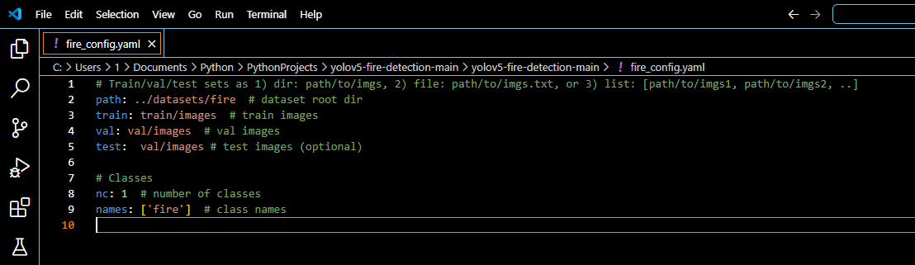

Figure 4-Training and Validation

Apply the included training script to your flame detection dataset to train the YOLOv5 model. Once the model achieves the desired outcome, integrate it to the Raspberry Pi. Ensure that the YOLOv5 model is compatible with the hardware constraints. During inference, YOLOv5 performs Image Preprocessing, it resizes the input image to a fixed size (e.g., 640x640) while maintaining aspect ratio, forward Passing, it passes the preprocessed image through the network to obtain predictions, and Non-Maximum Suppression (NMS), it filters out overlapping bounding boxes based on their IoU and confidence scores to provide the final set of detections.

YOLOv5 is optimized for accuracy and speed. It is designed to execute effectively on both CPU and GPU, making it ideal for real-time applications and it has many variants, it is available in various sizes (e.g., YOLOv5s, YOLOv5m, YOLOv5l, and YOLOv5x) to balance speed and accuracy based on application needs.

By taking this thorough method, you can efficiently train and deploy a YOLOv5s model for flame detection on a Raspberry Pi while ensuring that it meets the required performance criteria and hardware constraints.

To ensure that fire detection and suppression works seamlessly when there is a real fire, we considered implementing a machine learning model at the end of our process, because YOLOv5 might predict an image of a fire as a fire not a real fire. So, we intend to aggregate sensor values into our project, train a model on a real dataset to predict if we should extinguish or not.

Our proposed model is a Random Forest trees model that is based on supervised learning. This is to ensure maximum success rate since we are working with data we know. Random forest trees creates multiple decision trees to reach an accurate prediction/result. A decision tree is a supervised learning algorithm which is utilized for both classification and regression tasks. It has a hierarchical tree structure which consists of root node branches, internal nodes and leaf nodes as seen in Figure 5.

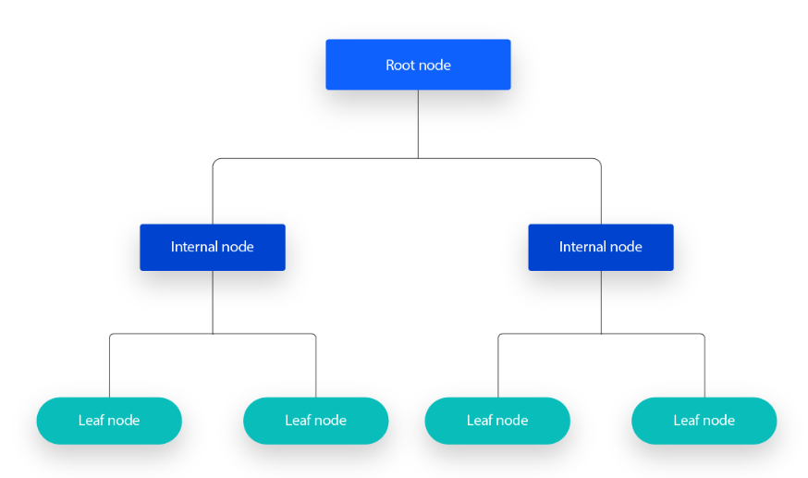

Figure 5- Decision trees-https://www.ibm.com/topics/decision-trees.

The process of splitting nodes in a decision tree involves selecting the best feature to divide the data based on specific criteria, such as information gain and the Gini index. Information Gain measures the reduction in entropy, where entropy is a measure of disorder or impurity in the dataset. It is calculated as the difference between the impurity of the parent node and the average impurity of the child nodes, favoring splits that result in purer child nodes. The Gini Index, another splitting criterion, quantifies the probability of incorrectly classifying a randomly chosen element if it was labeled according to the distribution of labels in the node.

An example of decision trees is someone checking a job offer as seen in Figure 6.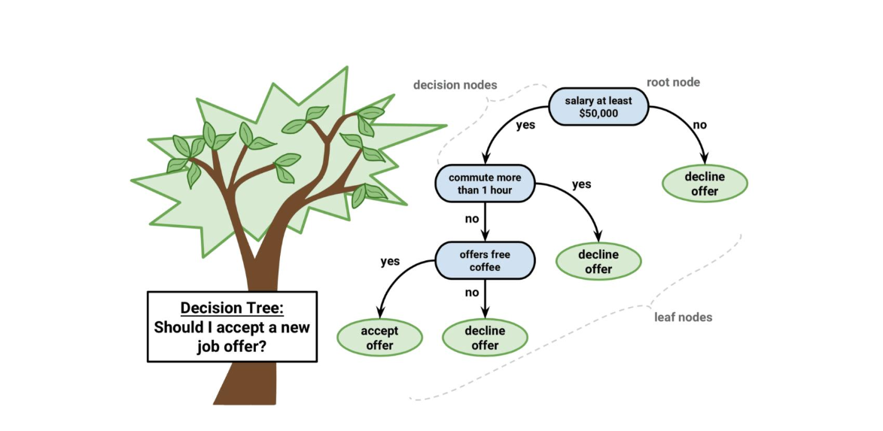

Figure 6- Decision Trees example.

In a random forest, multiple decision trees are trained using different subsets of the training data and features as seen in Figure 7, enhancing the robustness and accuracy of the model. Each decision tree in the forest follows the principles of node splitting based on criteria like Information Gain and the Gini Index. A higher Information Gain or a lower Gini Index indicates a better split. Trees in the random forest continue to split until they meet a stopping criterion, such as a minimum number of samples per leaf node or a maximum tree depth, preventing overfitting.

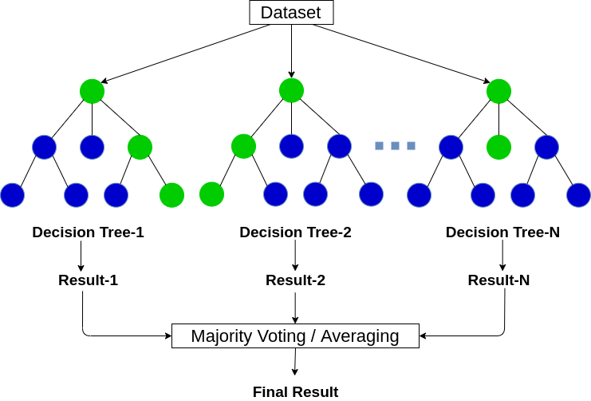

Figure 7- Forest Trees - https://www.analyticsvidhya.com/blog/2020/05/decision-tree-vs-random-forest-algorithm/.

We intend to implement these two models to ensure that fire is not just detected as a flame, but a real fire is detected to prevent errors while extinguishing.

## Mechanical Design:

The main component of our mechanical design is the robotic arm that should cover the room/ space. So, to be able to build and control a robotic arm there are several criteria to check in order to achieve the properties of solutions: DOF, DH Parameters, automated/manual, use of camera, and use of ultrasonic sensor. Check Table 3 for Robot Arm criteria.

Choosing how many DOF was an easy task, because one rotation is needed for the horizontal direction, and one for the vertical direction. Hence a 2 DOF robot arm is sufficient. One joint that rolls, and another that yaws.

So, we should have the base connected to a joint that rolls, then a link connected to a joint that yaws as shown in Figure 8. These joints will rotate with the help of servo motors.

Also, DH parameters are to be applied to rotate the robot arm to the desired location. There are 4 DH parameters. Link length, link twist, link offset, and joint angle.

Table 3-Cross referencing Criteria for Robot Arm

|  |  |  |  |  |  |
| --- | --- | --- | --- | --- | --- |
| Method | Modeling and Control of 2-DOF Robot Arm | Design of 2 DOF arm robot control system using  ultrasonic sensor | ROBOTIC ARM WITH REAL-TIME IMAGE PROCESSING USING RASPBERRY PI, BOTH AUTOMATED AND MANUALLY. | A Cost-Efficient Multipurpose Service Robot using Raspberry Pi and 6 DOF Robotic Arm | Required |
| DOF | 2 | 2 | 7 | 6 | YES |
| Use of DH parameters | Yes | No | N/A | Yes | NO |
| Automated/manual | man | auto | both | man | YES |
| Camera usage | No | No | Yes | Yes | YES |
| Ultrasonic sensor usage | No | Yes | No | Yes | NO |

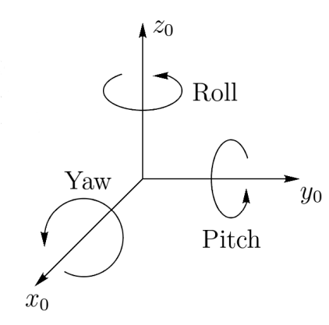

Figure 8 - Roll Pich Yaw

The great advantage of the Denavit-Hartenberg notation is that it allows us to describe a robot very concisely. So, for the 2-link robot arm , it can be described simply by a table as seen in Table 4. We have 1 column for each of the Denavit-Hartenberg parameters and we have one row for each joint of the robot arm.

Table 4-example of a DH parameter table

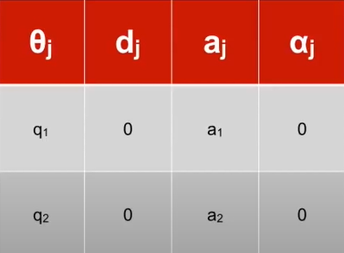

For the robotic arm, we should assemble a basic model robotic kit that has brackets that can move in both the x and y directions. We simulated it and viewed its rotation on Inventor Professional 2020 as seen in Figure 9.

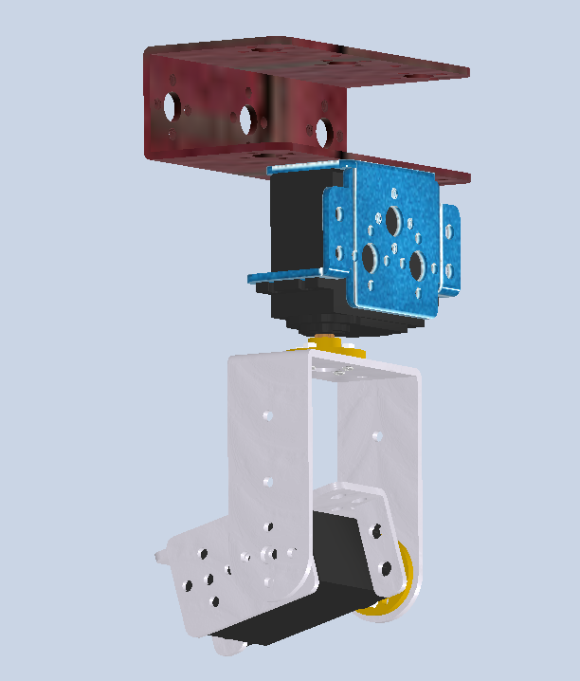

Figure 9-Robotic Arm Design

It has a rotating joint after the first servo and connected to the link another servo for movement along the y axis.

We chose the MG995 Servo motors as our main actuators to move the robotic arm. It is a high torque servo motor that is commonly used in robotics, RC cars, and mini projects. It has a torque of 10Kg.cm and rotates 180 degrees, which is sufficient for our arm movement. Check the appendix for more information.

Connected to the robot arm, is a hose that is placed on the end of the arm, in order to face the same direction as the robot arm for fire suppression, and a camera module connected to the controller. Connected on the other side of the hose is a water pump that turns on via an Arduino relay when the command is given. This also is connected to a water tank/water source. We used a 12V fuel/water pump for our prototype.

## Electrical Design:

Figure 10 showcases the electric design of our project. It consists of a Raspberry Pi that is connected to a PI Camera, and has serial connections to a NodeMCU32-S, which is connected to the MG995 servo motors, AMG8833 thermal imager, and MQ2 smoke sensor. We might need to implement a transistor circuit to get the desired voltage for the activation of the Arduino relay since the NodeMCU32–S only outputs 3.3v pins as well as some capacitors for decoupling and smooth motion of the motors.

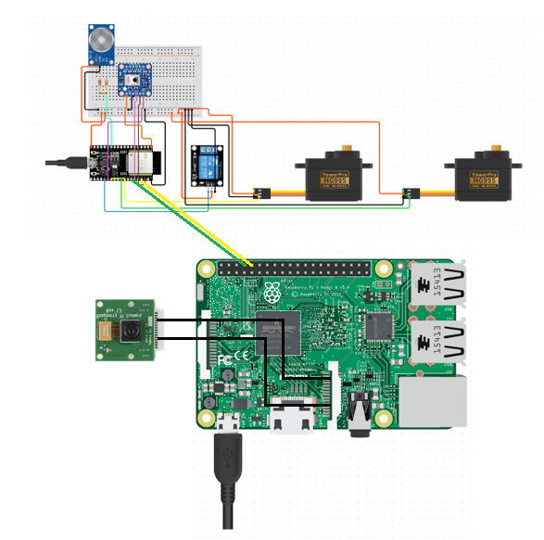

Figure 10- Partial Electric Design

# Risk Assessment:

When designing Smart Water Sprinkler System, several risks have been identified with aspects ranging from the reliability of the fire detection system to the mechanical and electrical components' functionality in Table 5.

Table 5- Risk Assessment

|  |  |  |  |  |
| --- | --- | --- | --- | --- |
| Risks | Description | Likelihood | Impact | Mitigation Strategy |
| R1 | Fire detection system failure | Moderate | High | Regular testing and maintenance of the AI model. Implement backup sensors for redundancy. |
| R2 | Robotic arm malfunction | Low | Moderate | Regular inspection and maintenance of robotic arm components. Emergency manual control option. |
| R3 | Water pump failure | Low | High | Regular maintenance and testing of the water pump. Implement backup water pump. |
| R4 | Electrical system failure | Moderate | High | Implement surge protection and backup power supply. Regular inspection of electrical components. |
| R5 | False positive fire detection | Moderate | Moderate | Implement a verification system and additional sensors to cross-check fire detection results. |
| R6 | Inadequate water supply | Low | High | Monitor water levels regularly. Implement alarms for low water levels. |
| R7 | Integration issues between software and hardware | Moderate | Moderate | Conduct thorough testing during development. Regularly update and patch software components. |
| R8 | Inaccurate robotic arm positioning | Moderate | Moderate | Implement feedback mechanisms for precise arm control. Regular calibration checks. |
| R9 | High-pressure water-related safety risks | Low | High | Implement safety mechanisms and pressure relief systems. Adequate training for users. |

# Testing and Implementation:

In this section, we will discuss the components and costs, the testing, and the implementation/ assembly of the system.

## Components and Costs:

For our project, we have compiled a list of sensors, actuators, and components that we will use for implementation found in *Table 6*. Check Appendix C: Components: for detailed information on the components.

Table 6- Components and Prices

|  |  |  |  |
| --- | --- | --- | --- |
| Component | Part number | link | Price |
| Smoke Detector | MQ-2 Smoke Gas Sensor | <https://electroslab.com/products/mq-2-smoke-gas-sensor-module?_pos=1&_psq=smoke&_ss=e&_v=1.0> | 3.00$ |
| Camera | Raspberry Pi B/B+ Official Camera 5MP | https://katranji.com/en/item/357715 | 5.50$ |
| Robotic arm | 2DOF Robot Arm with 3 MG995 Motors | https://electroslab.com/products/not-assembly-full-set-diy-2dof-robot-arm-manipulator-claw-1?_pos=7&_sid=1af8618b3&_ss=r | 55.00$ |
| Casing | Plexi Glass | N/A | 100$ |
| Raspberry pi | Raspberry Pi 3 Model B+ | https://katranji.com/en/item/426756 | 55.00$ |
| Water Pump | 12V Fuel/Water pump | https://katranji.com/en/item/478937 | 25$ |
| Arduino Relay 1 Channel | Relay 5V 10A | https://katranji.com/en/item/365048 | 0.6$$ |
| Power Supply | Computer Power Supply 12V,5V,3.3V | <https://katranji.com/en/item/335049> | 10.00$ |
| NodeMCU-32s | NodeMCU-32S | https://www.ubuy.com.lb/en/productcn/IEN3XPJLC-nodemcu-esp-32s-esp-wroom-32e-wifi-development-board-service-port-wifi-bluetooth-module | 7.00$ |

For more information on the parts and components, please check appendix C.

## Testing:

This section will showcase how we started testing all the codes and models in our project.

### YOLOv5:

For our first steps, we started by running Yolov5 on our personal laptops on a GPU as seen in Figure 11. We were able to get fantastic results with almost 20ms response time between each frame as seen in Figure 12.

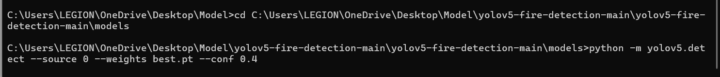

Figure 11- Running YOLOv5 on Personal Laptop with GTX1660Ti

Running YOLOv5 from the CMD, we specified the confidence, the source 0 which is camera for live feed, and our trained model (weights) which is best.pt for detecting fires.

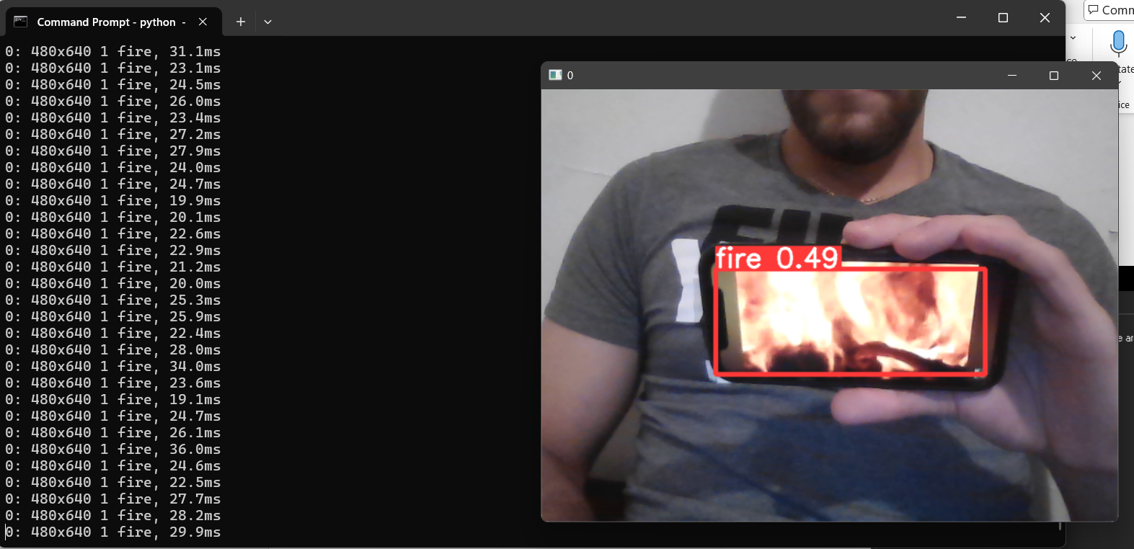

Figure 12 - Results on laptop.

When shifting from a laptop with a GPU to Raspberry Pi, we were able to process one frame every 2 seconds, which is not optimal. So, we decided to go for a lighter version of YOLOv5s trained data which is the TFLite version. We converted our pt file to a TFLite file using TensorFlow and TensorFlow lite libraries, which made us process each image every 600ms as shown in Figure 13.

We were able to achieve such speed improvement with the tensor flow light model because TF light is optimized for edge devices it has more efficient execution it provides lightweight runtime because it converts 32-bit floating point numbers to 16-bit, which is half.

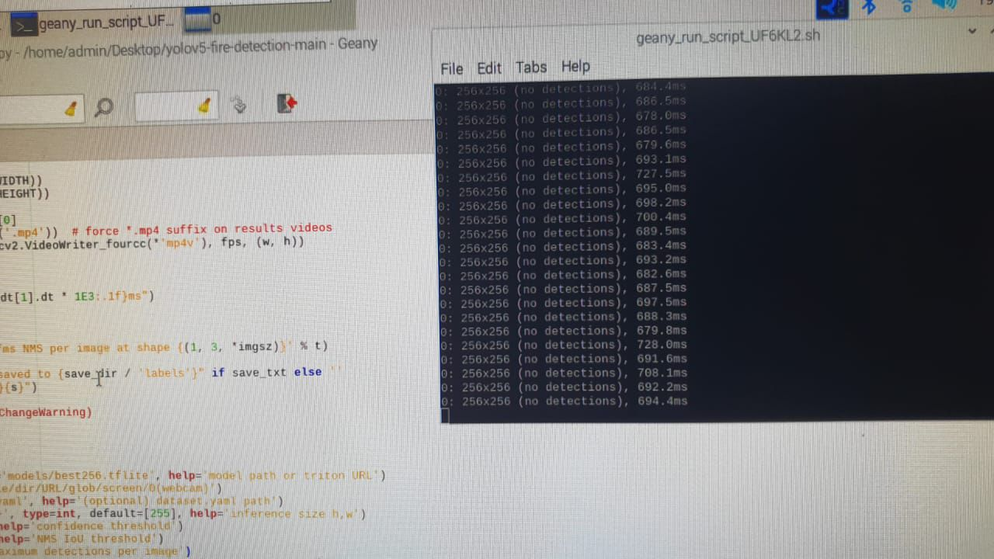

Figure 13 - Response time on RPi using TFLite.

To study the accuracy of our model, we imported the yolov5 metrics file, that enables us to get and sketch the accuracy, F1 score, recall, and sensitivity. In machine learning, each one of these resembles a ratio, discussed above in the preliminaries.

From testing real life examples. We were able to obtain the following scores illustrated below:

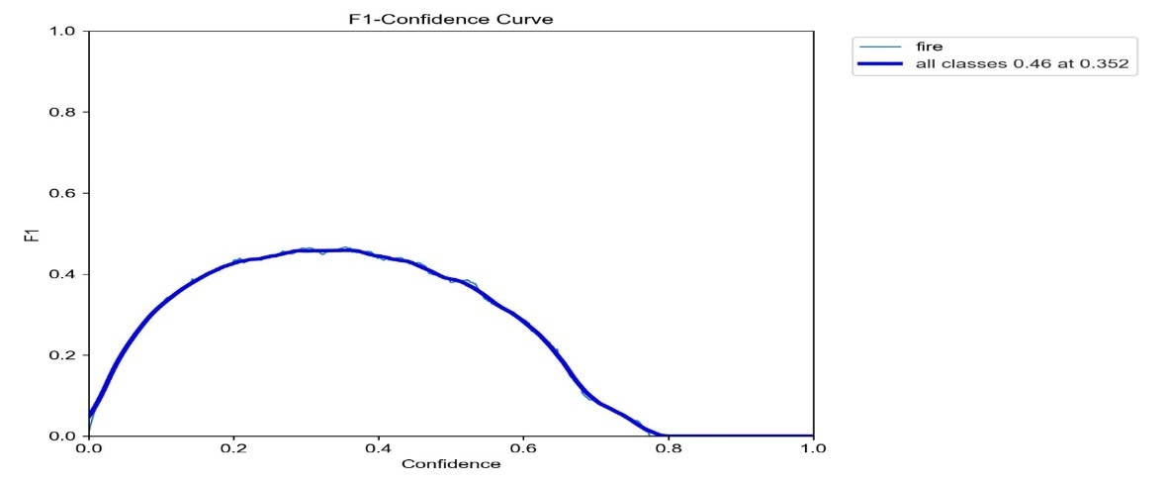

Figure 14 – Confidence.

The F1-Confidence curve in Figure 14 shows how the F1 score varies with different confidence thresholds.

The curve peaks at a certain confidence level, indicating the optimal balance between precision and recall. The peak F1 score of 0.46 at a confidence of 0.352 suggests this is the optimal confidence threshold for your model to balance both precision and recall effectively.

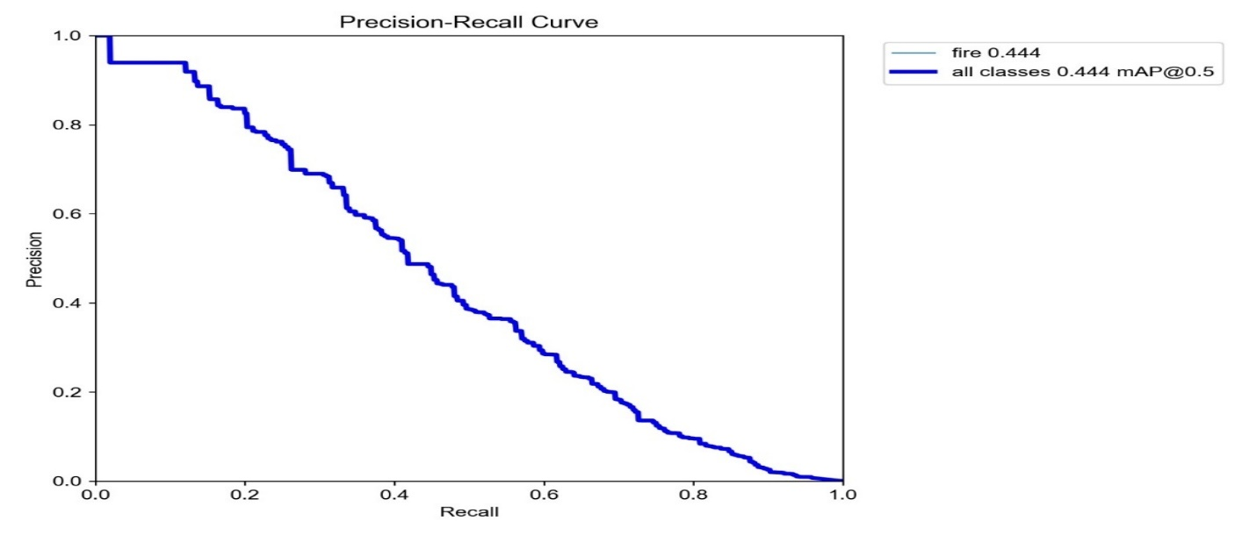

Figure 15- Precision Recall

The Precision-Recall curve in Figure 15 plots precision against recall. The curve for "all classes" suggests a moderate trade-off between precision and recall. The precision decreases as recall increases, which is typical in many models. The model has a moderate recall, which means it's correctly identifying a good portion of the fire instances but could miss some.

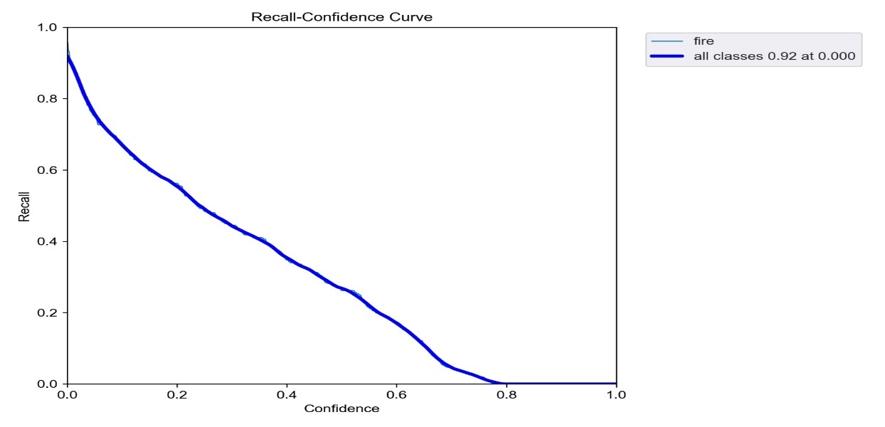

Figure 16 - Recall Confidence

The recall confidence curve in Figure 16shows how recall varies with different confidence threshold values. The curve shows that recall decreases as confidence increases. This means that at higher confidence thresholds, the model becomes more conservative, identifying fewer fires but with higher certainty. We already set our model to detect one fire at a time. The high initial recall indicates the model is able to detect most instances at low confidence thresholds.

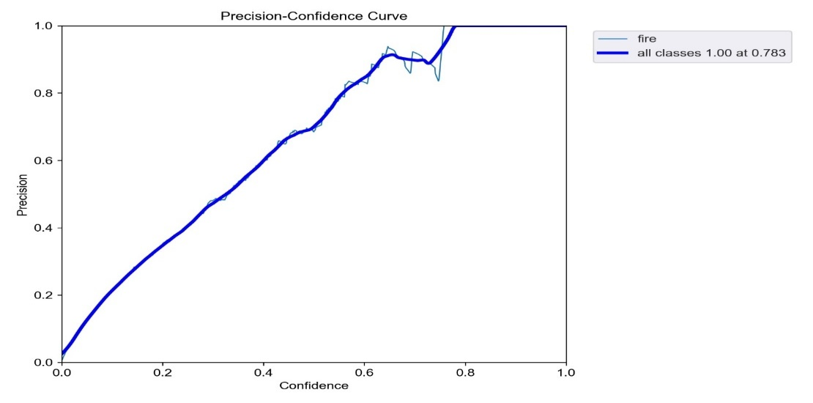

Figure 17 - Precision-Confidence

The Precision-Confidence curve in Figure 17 shows how precision varies with different confidence threshold values. Higher precision at lower confidence thresholds indicates that the model is making accurate predictions even with lower confidence. The overall curve for "all classes" is strong, indicating that the model maintains high precision across various confidence levels.

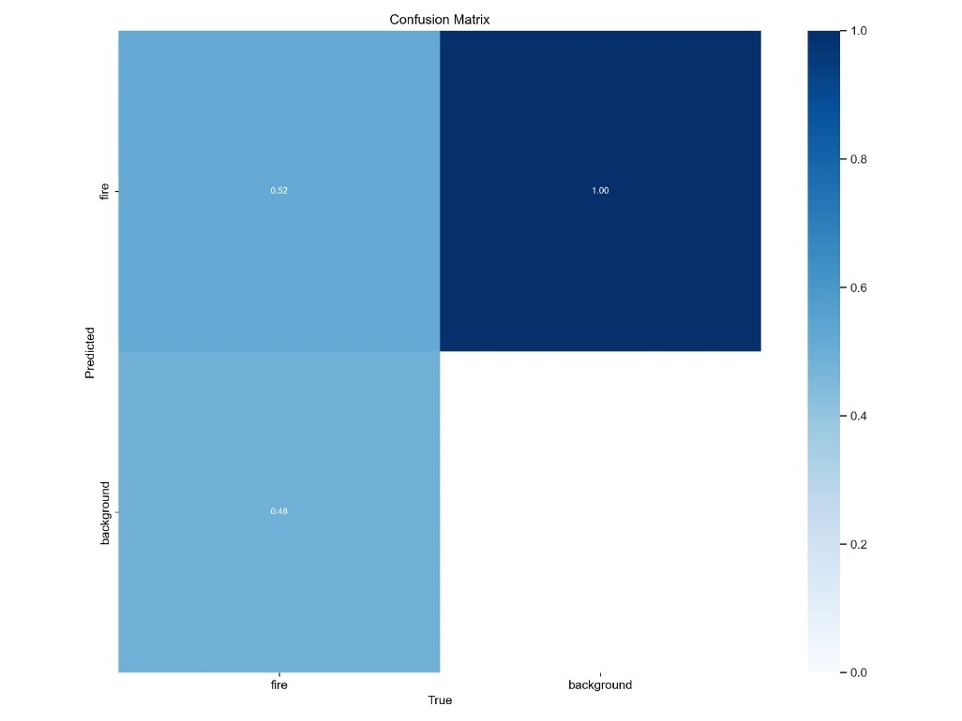

Figure 18- Confusion Matrix

The confusion matrix in Figure 18 shows the true positives, false positives, true negatives, and false negatives for the predictions. The confusion matrix indicates that there are:

True Positives (fire correctly identified as fire): 0.52.

True Negatives (background correctly identified as background): 1.00.

False Negatives (fire incorrectly identified as background): 0.48.

False Positives (background incorrectly identified as fire): 1.00.

The model is better at identifying the background correctly but struggles more with identifying fire correctly (high false negative rate).

These graphs illustrate our metrics, and enable us to prove that our model is working as needed.

In the Detect script of the YoloV5 model, we are importing the ServoAngle.py file at line 61 as shown in Figure 19, and calling the XYToAngles function on line 199 seen in Figure 20 to calculate the coordinates of the fire detected, and the Sweep on line 220 seen in Figure 21.



Figure 19 -Importing.

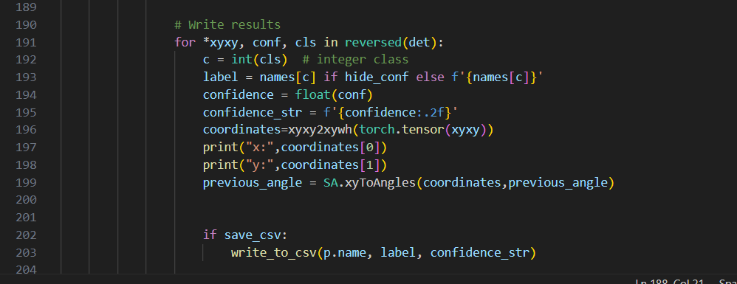

Figure 20- Angles.



Figure 21 -sweep.

These functions will be explained in the coordinates section.

### Coordinates:

In this part, we worked on getting the right angles for the servos to turn to the bounding box generated by the model. First, we had to take the vertical and horizontal camera’s fields of view as well as the width and height of the image captured by the camera as shown in Figure 22.

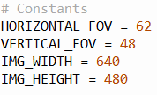

Figure 22 Constants.

Then we had to define the serial port and the baud rate for the NodeMcu32S to communicate properly with the raspberry pie while the Yolov5 model is in action. We also had to do some initializations for the servo motor angles before rotating each as needed. To be able to move the servos automatically when fire is detected on the raspberry pi, we used the function in Figure 23.

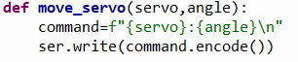

Figure 23 Move Servo Function

This function takes the name of the servo and the angle we want to move it to using a string command sent by the serial connection to the NodeMcu32S which decodes the command and executes it.

The angles were initially set to 90 on the x_servo and 140 on the y_servo with a flag to make sure that it is always initialized to these values when the model starts. The new angles were obtained using mathematical equations where we got the center of the red box, containing the fire, in coordinates form.

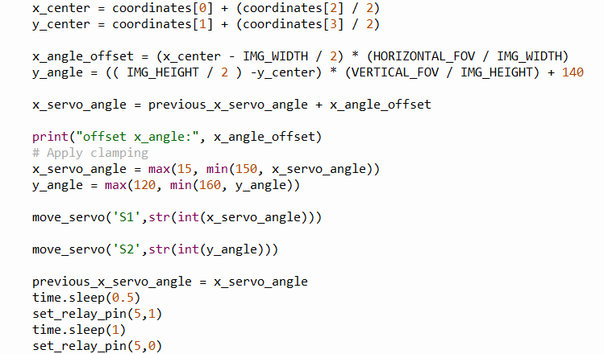

Figure 24 Code Snippet

After getting to the center of the red box we used the equations shown in Figure 24 to get the new X_angle and Y_angle with an offset on the X_Servo discovered through experimentations. Before sending the new angles to the servo motors we had to apply clamping to them so that they rotate in a specific range without damaging the robot arm or the camera. When the motors are set as desired the relay shall turn on for a small amount of time and then off to turn on and off the extinguisher using a function similar to the move servo which allows communication between the two controllers.

### Serial Communication between Raspberry Pi and NodeMCU32-S:

To successively control the motors and obtain analog input, we relied on the NODEMCU for the PWM pins and analog inputs. We created a serial connection between the Raspberry Pi and NODEMCU32-s in order to send data back and forth. We need to send information from the RPi regarding the coordinates to the ESP32, so that it controls the motor. We saw in the Coordinates section above how we are using the Raspberry Pi to write serial so that the ESP can read.

On the NodeMcu32S side we implemented a function which makes sure that we are in automatic mode with the Yolo model working before controlling the motors and relay. In this mode the controller checks for serial connection availability before decoding the command coming from the raspberry pi as seen in Figure 25.

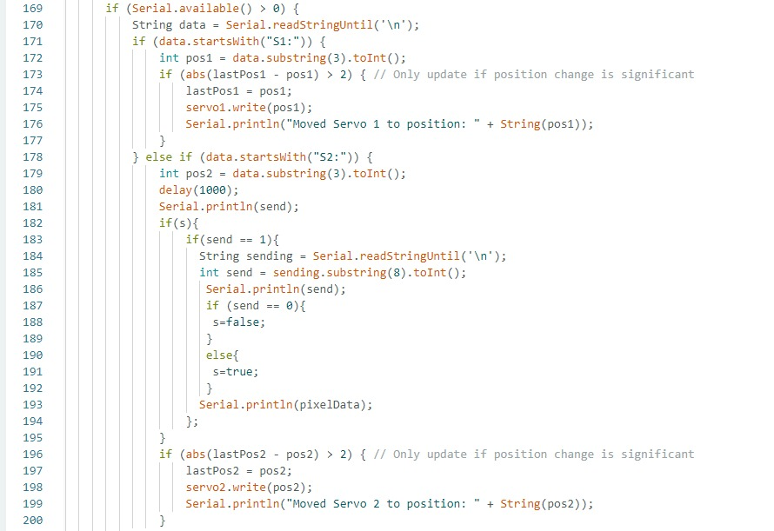

Figure 25 Code Snippet that sends servo and sensor values.

As we see in the code snippet above, the controller checks if the string sent from the raspberry pi starts with ‘S1’ or ‘S2’ to know which servo it needs to move to the new position using the servo.write() function which is a built-in function that sends the new position to the servo motors via the PWM pins. We are also reading the values from the thermal sensor and smoke sensor after the x_servo moves with a small delay for accurate readings. In addition to the servo motors, if the sent string starts with ‘D’ the relay is turned on or off according to the command. Check appendix for full code.

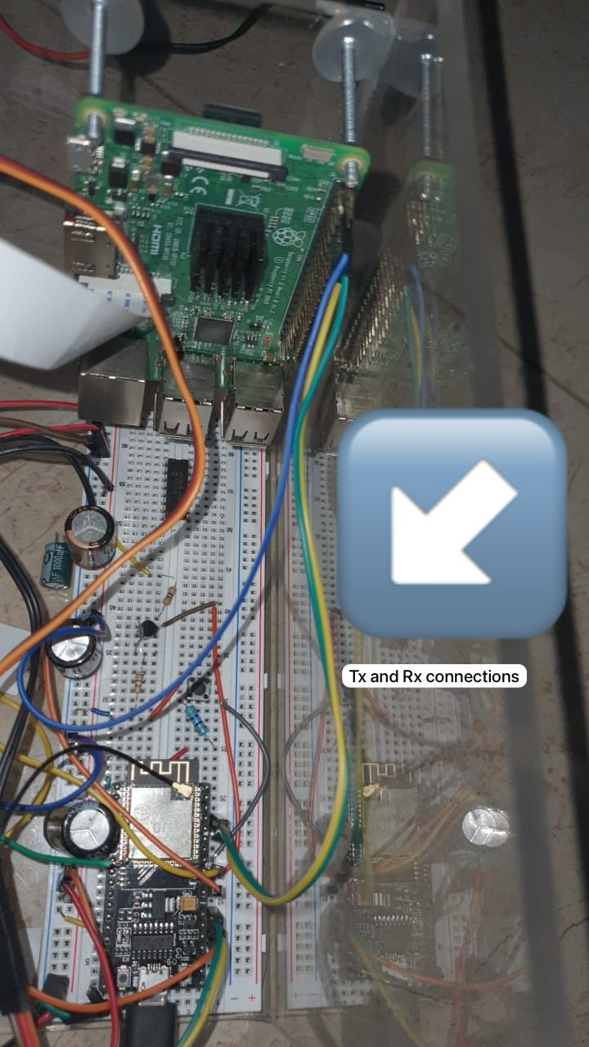

Figure 26 Serial Connection

As for reading on the Raspberry Pi we implemented a function that reads serial in Figure 27 via the wires shown in Figure 26.

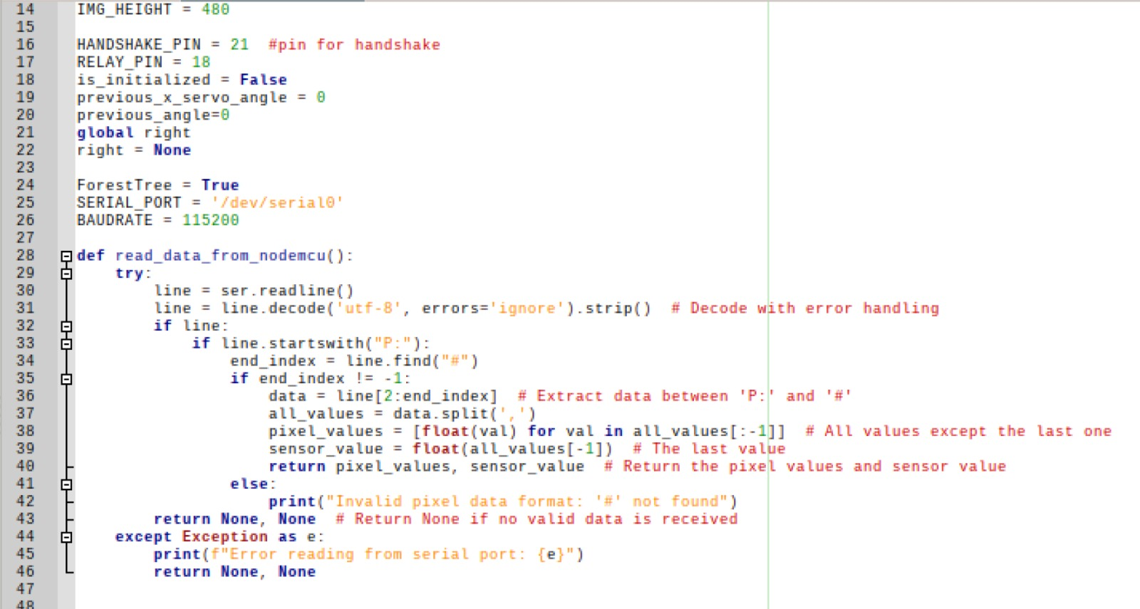

Figure 27 - read from node MCU.

### Sensor implementation:

To ensure that real fire is detected, we chose to implement a thermal imager AMG8833 and a smoke sensor MQ-2, along with the YOLOv5 model. To test these sensors first separately, we implemented the smoke sensor on an Arduino Uno first. We connected the sensor to the analog pin and measured the amount of smoke in the room as seen in the setup in Figure 28.

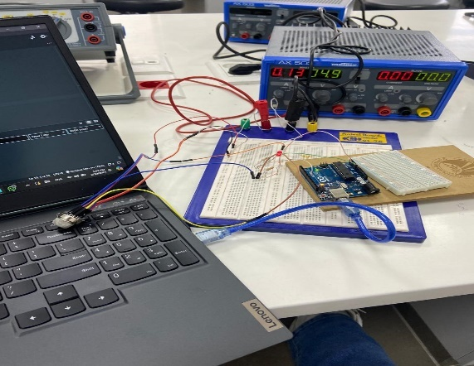

Figure 28-Smoke sensor setup.

The smoke sensor has 6 pins, 2 A pins that should be connected together, two B pins that should be connected together, and two heater pins one positive and one ground, then we connect a wire from the B pins to the analog input on the Arduino.

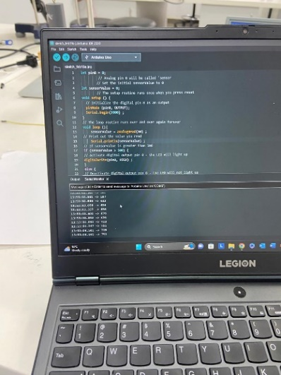

Figure 29- results.

The sensor gave values ranging from 500 to 700 on normal air conditions, while gave 800+ on smoke or gas detection as shown in Figure 29 and Figure 30. This initial testing was on Arduino Uno that has 10-bit analog input, so values range from 0-1023. We will then implement it on NodeMCU-32S that has 12-bit analog input so values will range from 0-4095.

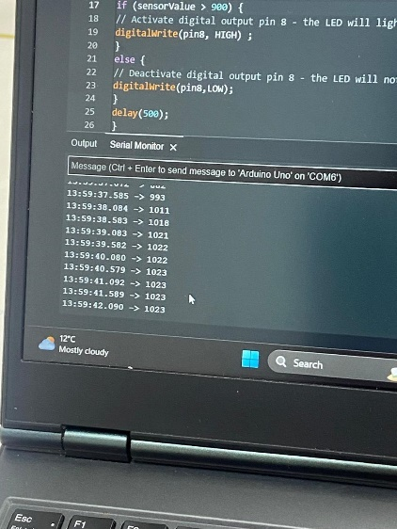

Figure 30- Results on Smoke

Check the appendix for full codes.

For the AMG8833 imager, we set it up on the NodeMCU-32S, and we used Thonny IDE on our laptop to generate a heatmap to visualize what is happening. AMG8833 outputs an 8x8 array as seen in Figure 31, which has a range of almost 7 meters.

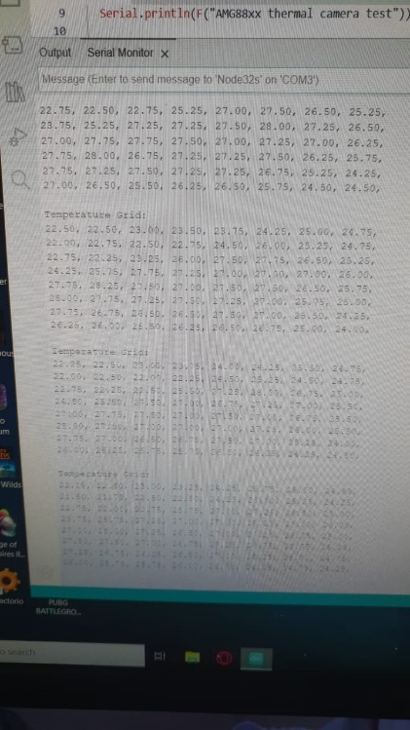

Figure 31 - Array from AMG8833

As seen above, we were able to extract the array and print it on the serial monitor using the code snippet in Figure 32. Check appendix for full code.

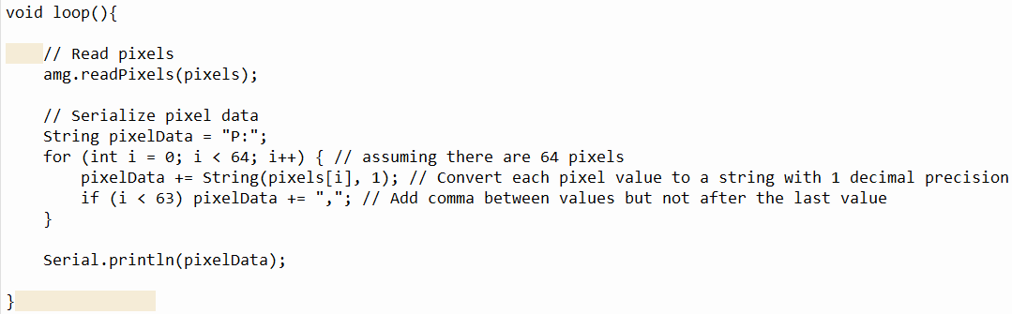

Figure 32- Code snippet.

We created an object AMG using a specific library for the sensor, and used it to read values.

To visualize it, we used python with matplotlib to generate a heatmap as shown in Figure 34.

The python script in Figure 33 reads on the port what is being printed by the NodeMCU and uses the data to generate a heatmap.

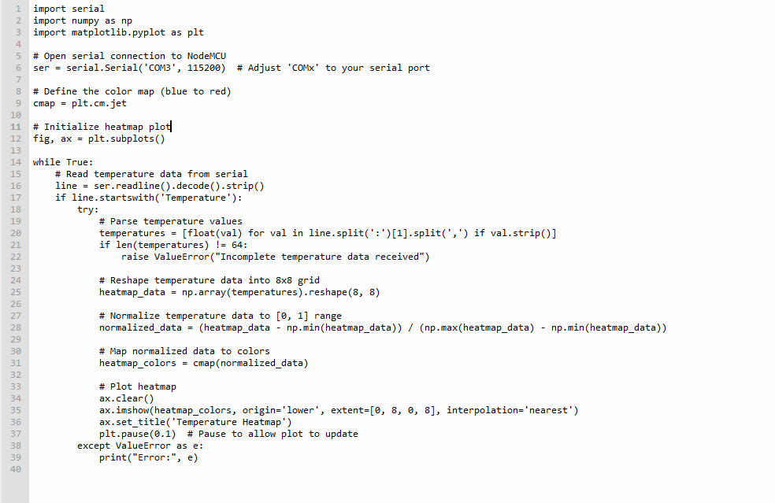

Figure 33- Heatmap Code

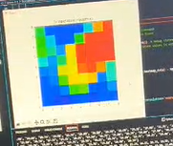

Figure 34- Heatmap.

This way, we were successively able to see what is happening, and ultimately utilize it for further integration in our system.

### Manual/AUTO:

Manual to auto switching is a feature created to expand the use of the fire extinguisher. It also adds another level of control. The implementation is done by creating the flag automatic in the NodeMCU script seen in Figure 35. This flag is set to true by default but can be switched by the webpage Monitor and Control. While on automatic the NodeMCU is controlling the servo motors by receiving serial data from the raspberry pi. If in the manual position the NodeMCU uses the website to receive servo angles from user.

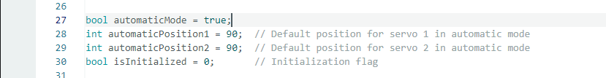

Figure 35 code snippet automatic Mode.

Initialize automatic mode flag to true and set up default positions for servos.



Figure 36 code snippet mode switching form.

Then we created a form to handle an action when the automatic to manual check box is clicked as seen in Figure 36.

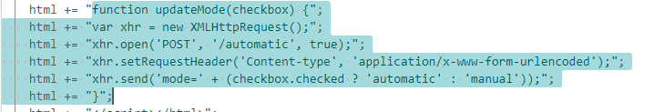

Figure 37 code snippet is function for auto/manual switching.

We handled the switching of the auto to manual mode without leaving the page as seen in Figure 37.

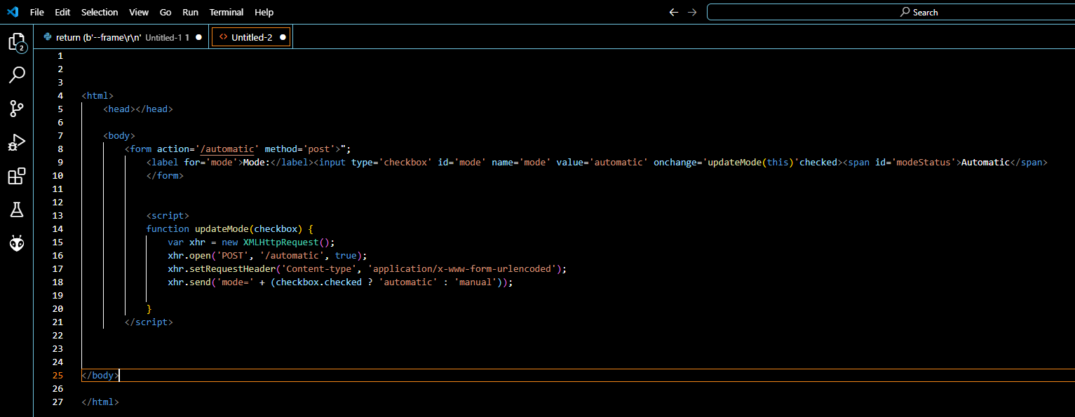

Figure 38 code snippet form + js function.

Form and JavaScript code for automatic to manual is shown in Figure 38.

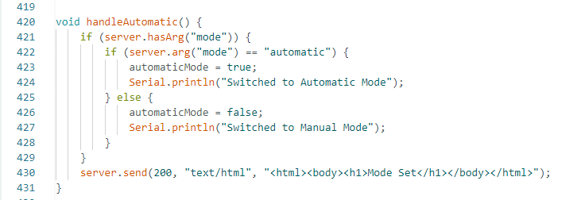

Figure 39 backend function auto/manual.

Backend flag switching after the check box is pressed the server sends the mode value in Figure 39.



Figure 40 code snippet backend handling.

Connecting backend and frontend for backend handling as seen in Figure 40.

### Broadcast:

This is a script written in python that uses Flask, a lightweight Python web framework. It also uses the pillow library to capture screenshots of the whole screen. After that the images are served inside the <img> tag in the html page. The webpage can be accessed by entering the Ip address of the raspberry pi and the port 5000. Check Figure 41 for the script.

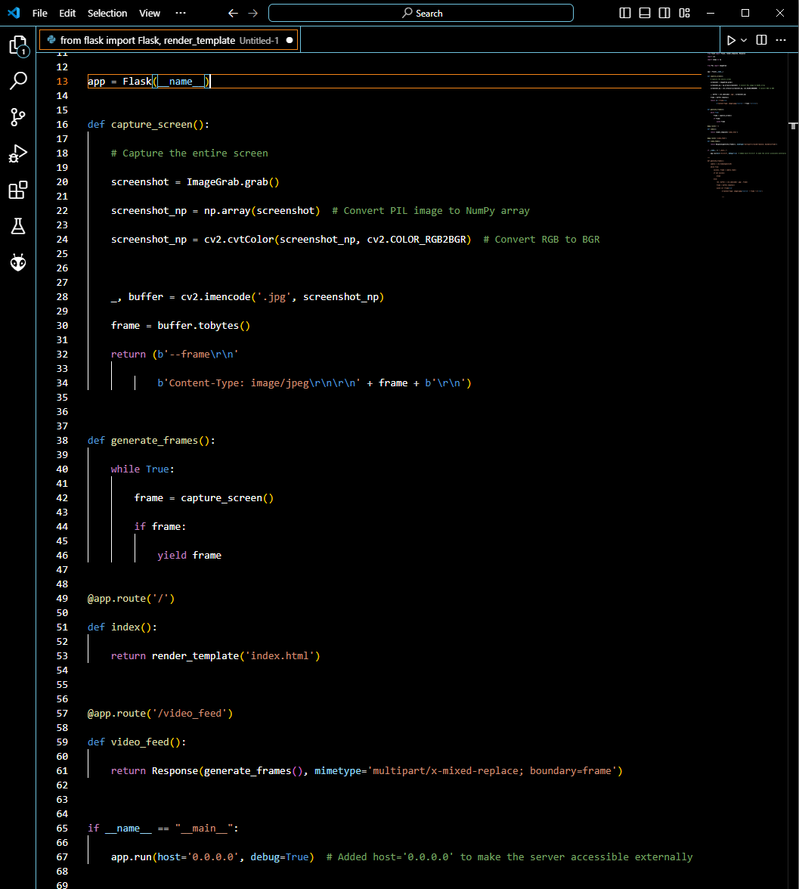

Figure 41- Broadcast.

### NodeMCU:

The NodeMCU-32S is a development board based on the ESP32 chipset, capable of running up to 240 MHz, which provides substantial speed for IoT applications. It features integrated WIFI and Bluetooth, numerous GPIO pins with support for various protocols, and ample memory for complex projects. We used this chip due to its hardware PWM pins that provide an accurate signal to the servo motors in addition to the analog pins that the raspberry pi doesn’t have. Moreover, we leveraged its capability to act as a WIFI station and/or access point to create a webpage interface. In the webpage there are 2 scenarios either the chip has been initialized with the Wi-Fi name and password in this case it attempts to connect if not successful after 30 attempts it aborts connections and resumes to the default automatic state which takes angle values for the servo motors from the raspberry pi along with relay value. The NodeMCU has an added functionality of resetting the initialization after a pushbutton has been pressed for 5 sec the chip will restart and with the initialization being false it acts as an access point and provides a WIFI signal along with a gate way Ip address to access a webpage that contains a 2 text fields for WIFI SSID and password and a submit button. Once the button is pressed the chip restarts and the initialization flag becomes true thus the system attempts to connect. After a successful connection the chip hosts a website for monitoring and controlling the system. This is achieved by having a live feed of the camera along with a check box to switch between automatic and manual mode. Once the manual mode has been chosen the chip will redirect the control of the servo motors and the relay to the user. See all the functions implemented in Figure 42.

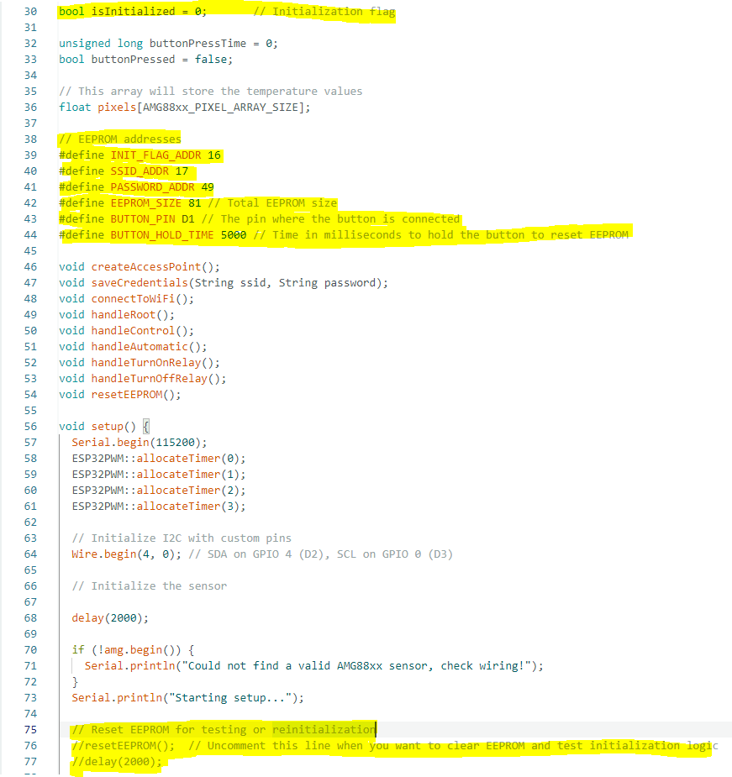

Figure 42 code snippet Initialization start.

Using EEPROM a writable non-volatile memory, to write and read the initialization flag the WIFI name and password as seen in Figure 43.

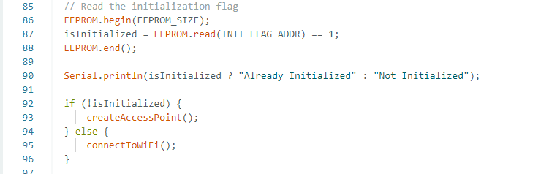

Figure 43 code snippet read initialization flag.

The EEPROM reads the initialization flag at the address INIT_FLAG_ADDR if it is true the value is saved inside it else it stays false.

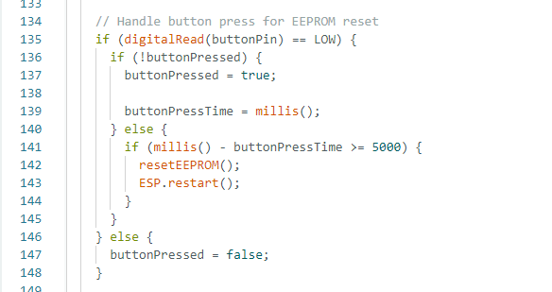

Figure 44 code snippet reset button.

When the button is pressed the time is taken and at the falling edge then the current time is subtracted from the time the button was pressed the result is the time the button is held down. If that time exceeds 5 seconds, the EEPROM is reset, and the ESP does an automatic restart to return to the initialization page as shown in Figure 44.

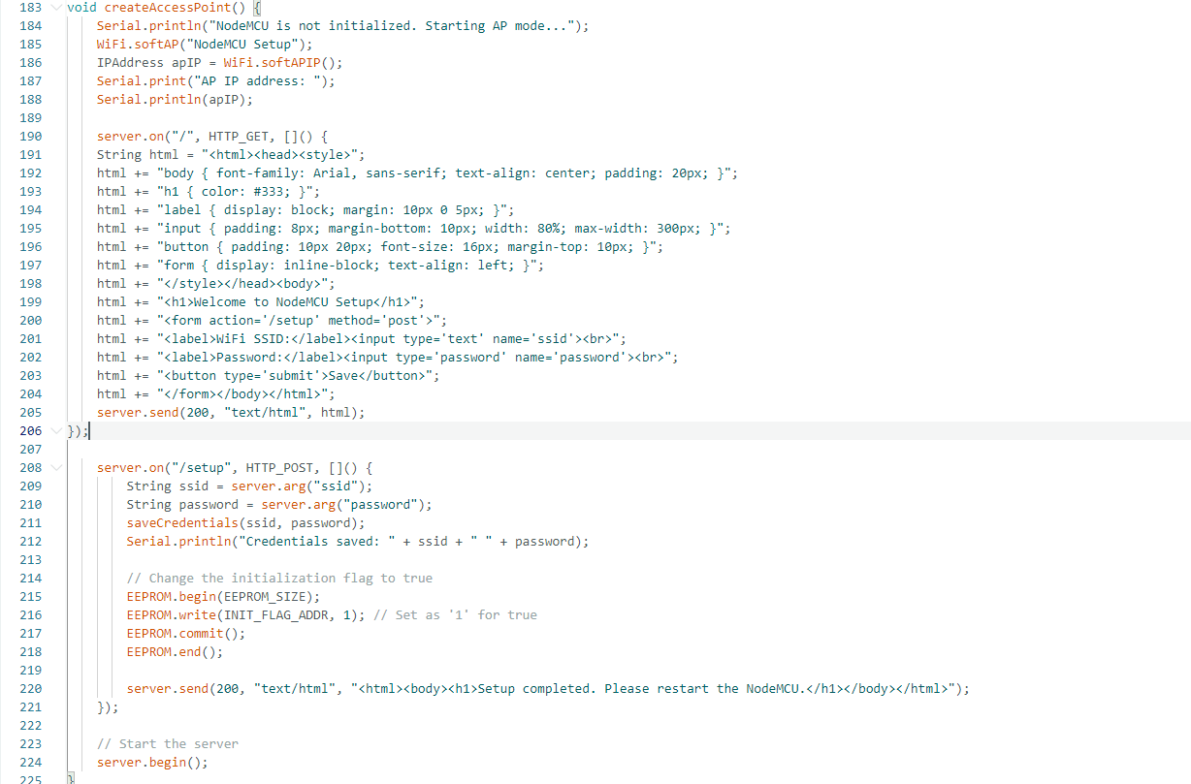

Figure 45 code snippet AP function.

An access point is a device the emits WIFI signal so other devices can connect to it. The NodeMCU is capable of connecting multiple devices to itself and can create a web page on its gateway Ip address. In our case this webpage is the initialization, the setup seen in Figure 45.

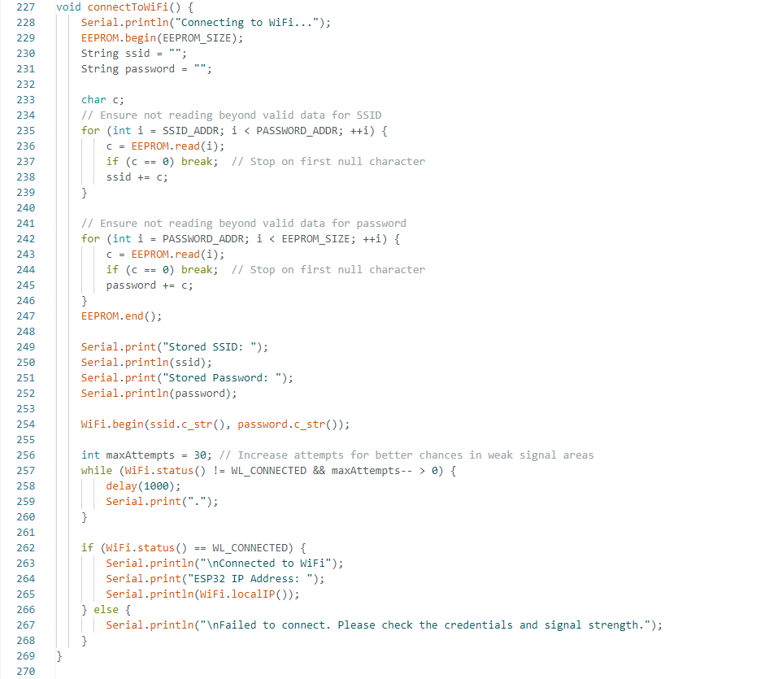

Figure 46 - connecting to WIFI.

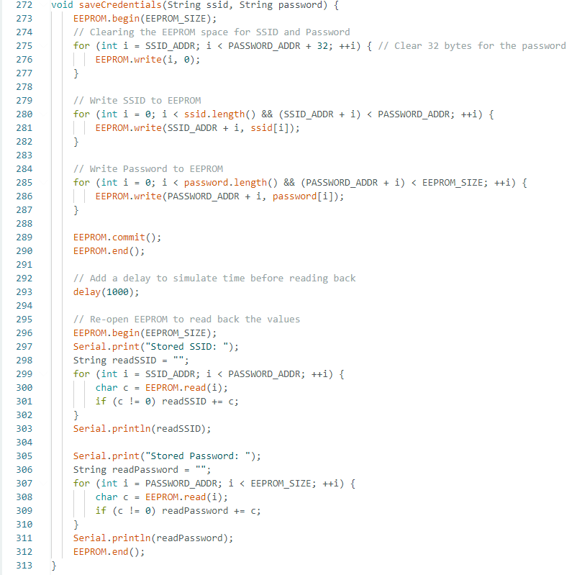

Figure 47 - Saving Credentials

### Run On Startup:

We implemented a script to run our project the startup as seen in Figure 48.

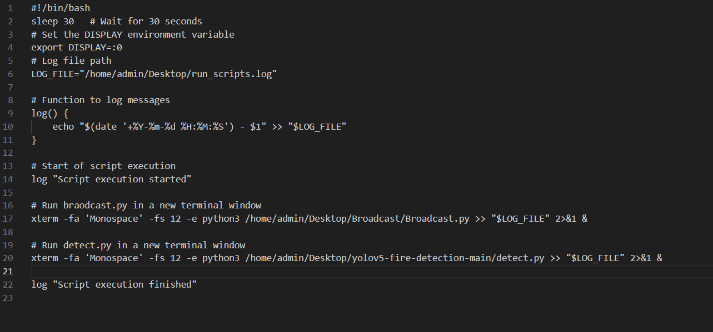

Figure 48 - Bash startup script.

This script makes the controller wait for 30 seconds before setting it up for graphical applications. It logs into a specific log file to run the two python files (camToWeb.py and detect.py) on startup of the raspberry pi.

### Random Forest Trees Model:

For ensuring perfect fire extinguishing, we integrated YOLOv5 with the sensors and implemented a random forest trees model on them. The model takes a real dataset from the sensor values, while normalizing the temperature data into one average value of the center 4x4 array as seen in Figure 49.

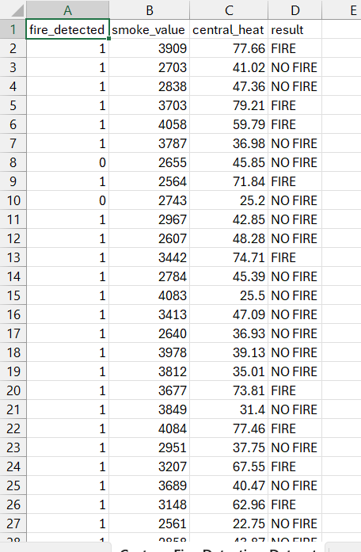

Figure 49 - Fire Dataset

The bounding box gives 1 if existing on YOLOv5, the smoke sensor has values from 0-4095, and the thermal imager has a function that calculates the average of the central array 4x4.

The model is then generated and trained using Sk-Learn, and a model file was created to be imported when needed as seen at the s=end of the script in Figure 50.

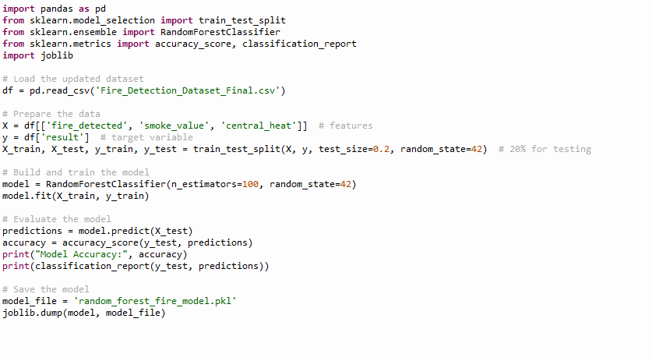

Figure 50- MODEL.

By choosing the test size as 0.2, 80% data for training, we were able to generate a perfect model as seen in Figure 51. It was expected since random forest trees is a method of supervised learning.

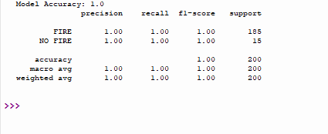

Figure 51 - Metrics.

To manually test the model, by giving it values to predict, we used the generated pkl file in another script, and gave it manually numbers for fire detected, thermal imager array, and smoke value, and the output was “Fire” or “No Fire” as seen in Figure 52.

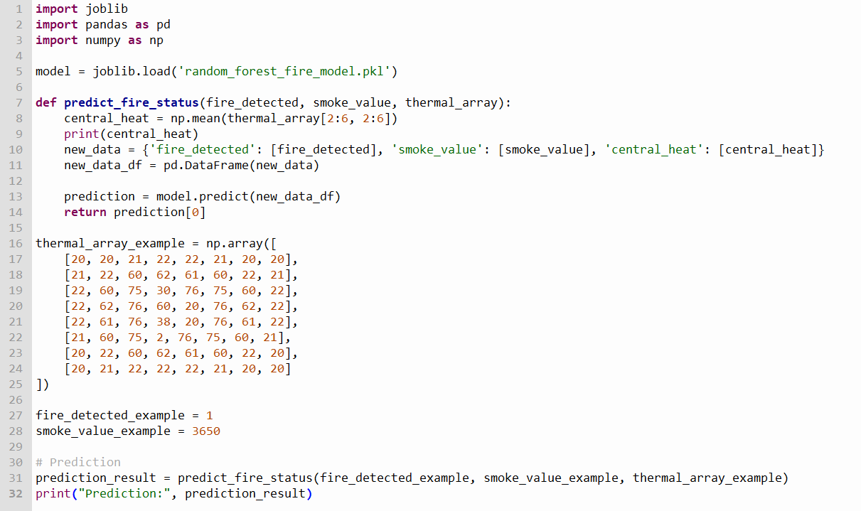

Figure 52 - Predict Script

As seen in the code above, we gave manual values for the sensors and the model, and predicted using many use cases as seen in Figure 53.

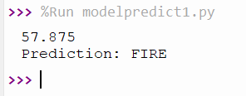

Figure 53 - Prediction result.

From here, we should move on to taking the sensor values from the actual sensors, send them via serial from the NodeMCU to the Raspberry Pi, to implement the model prediction on it to check if fire should be extinguished or not.

### YoloV5 with Random Forest Trees:

YoloV5 is capable of detecting both flames and fires. So, if an image of a flame is captured, it does not need to be extinguished. That is why our sensors and Random Forest Trees model play a crucial role in the successive detection and extinguishing of a fire. We used the code from the random forest trees model in the previous section and added it to our system. We imported the pkl file in our yolov5 detect.py to make it load at startup.

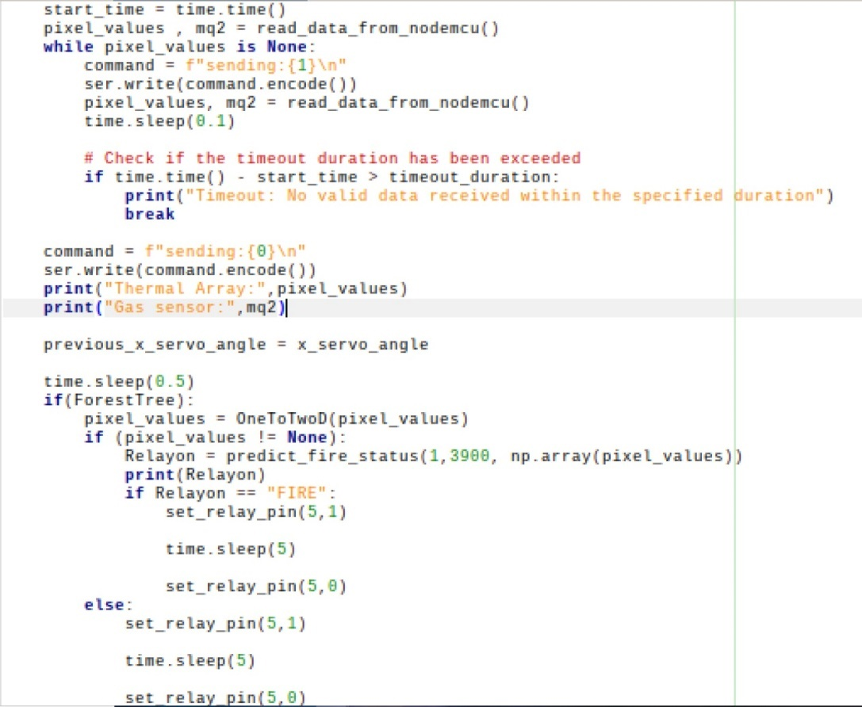

Figure 54 - Forest Trees implementation on Project.

The snippet shown in Figure 54 reads the data from the NodeMCU, gets the sensor values, and activates the forest trees model in the “predict_fire_status” function.

Our system should now be able to differentiate between flames and fires.

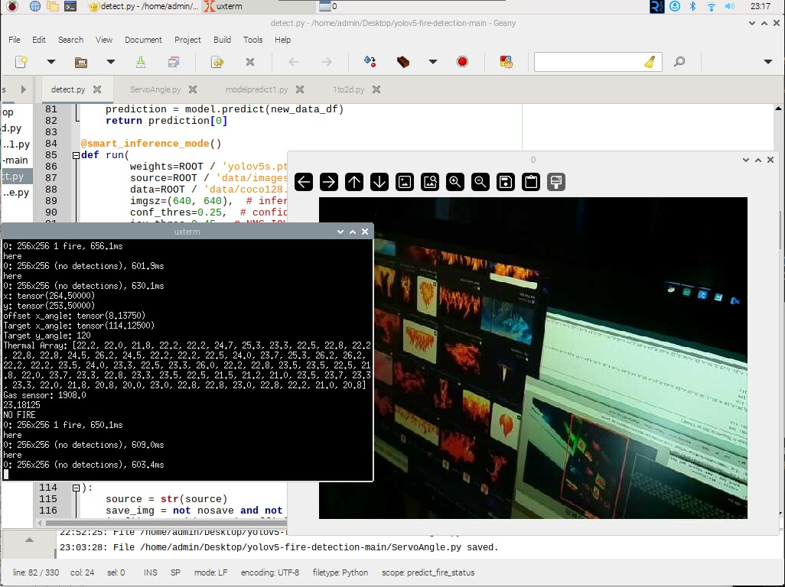

Figure 55- NoFire.

As seen in Figure 55, the system saw a flame, saw that there was no heat in the area, and predicted no fire.

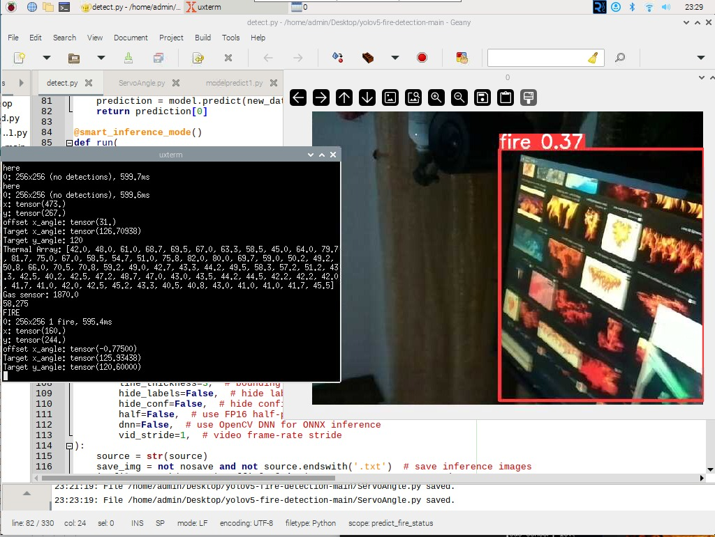

Figure 56 – Fire.

In our testing in Figure 56, we let YOLOv5 see a flame, but we separated the position of the camera and the thermal imager and added heat in front of the imager, for safety reasons testing indoors, we were able to predict fire.

## Assembling the System:

For budget and Prototype purposes, we chose to implement our project on a small scale, an 80x80x40 cm enclosure of transparent Plexi glass. All the electronics are fitted in a 30x25x25 cm box to preserve the electronic devices from water and fire, and this box is fitted at the top left of the enclosure.

### Assembling the arm:

We assembled the 2-DOF robotic arm kit and tested the servo mg995 motors initially as shown in Figure 57.

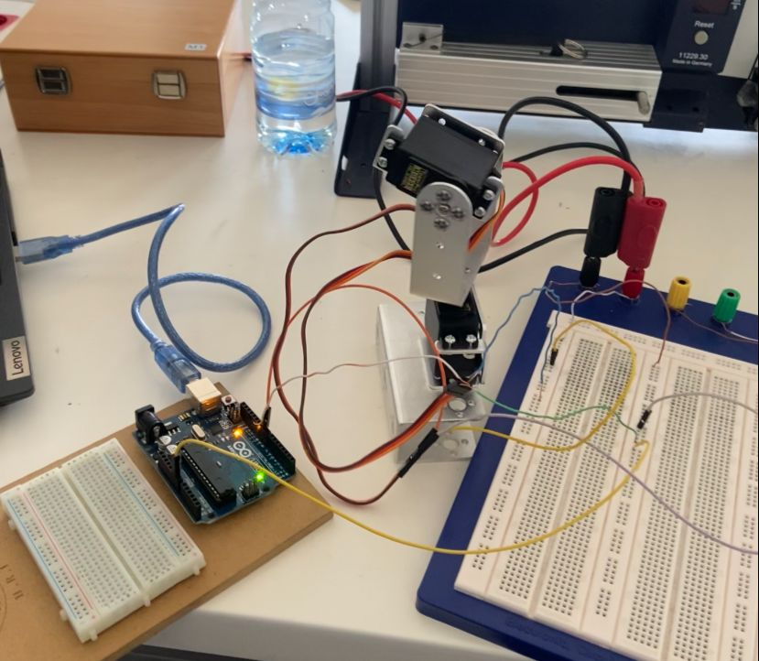

Figure 57 - arm Assembly.

### Electronic Setup:

We placed the Raspberry Pi, ESP32 NodeMCU-32S, Smoke sensor, thermal imager, Relay all in this small enclosure, and added a 450W power supply that supplies 3.3V, 5V, and 12V for powering up the devices. We also implemented a transistor circuit to turn on the relay switch because it requires 5V and the ESP PWM output 3.3V, all shown in Figure 58.

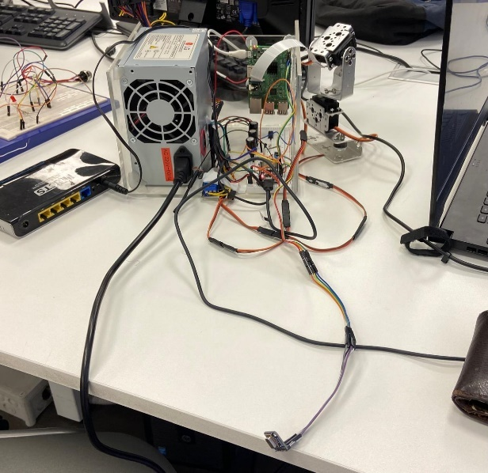

Figure 58 - electronic setup.

### Camera Arm Connection:

We fixed the Raspberry Pi camera on the X servo motor as seen in Figure 59, the motor will be sweeping so the camera will have a higher field of view.

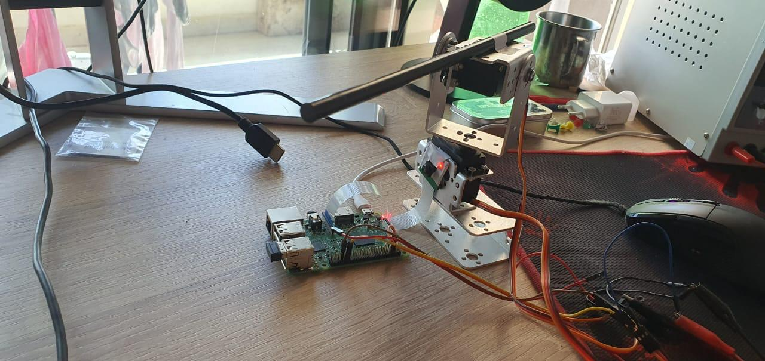

Figure 59 - Camera setup.

We then attached the thermal imager as well on the x servo motor.

### Case Setup:

We drilled the top of the case for attaching the arm to its ceiling as seen in Figure 60, we made holes for water pipe and power supply cable, and we fixed the box at the top of the enclosure.

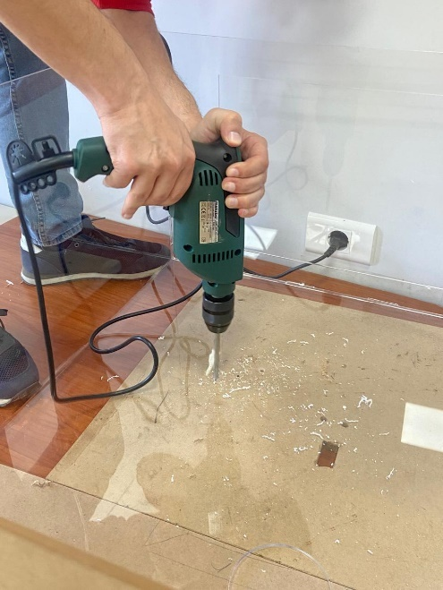

Figure 60 - drilling for the arm.

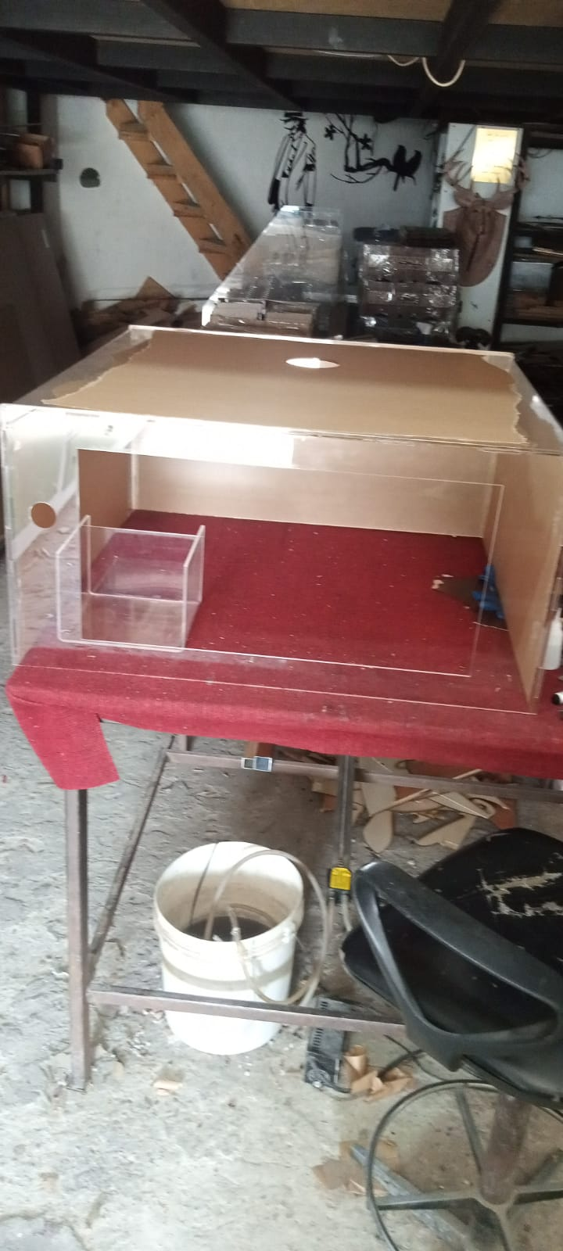

Figure 61 - Case.

This is how the case is designed as seen in Figure 61, with a door for ease of access.

### Full Assembly:

For the end product, we mounted the water hose on the servo Y, and set up inside the enclosure by fixing the arm and the small housing.

# Conclusion and Future Work:

When it came to actually testing the system in action, we set up at the university outdoors, lit a flame, a sprayed water as seen in Figure 62.

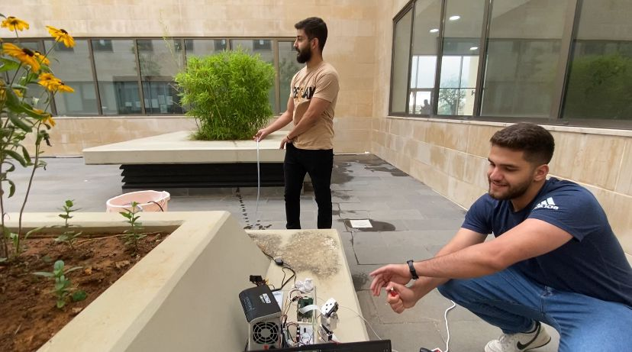

Figure 62 - Outdoor Testing

We were able to extinguish only in cases of a real fire as shown in Figure 62, which shows that our end goal is reached. We were able to add to the normal known YOLOv5 for fire detection by the integration of sensors to determine that a real fire is detected. This also proves that we were able to extinguish the fire at the location it is present.

Our Project is now successful. We were able to create a fire extinguisher that is smart that can detect not just flames, but a real fire by implementing YoloV5 and a random forest trees model on a Raspberry Pi, pared up with a NodeMCU-32S that controls the motors that target the fire, and has a web page that enables live feed from the camera with automatic and manual modes.

We can say that the successful literature review helped us design the project mechanically, electrically, and from a software basis, which made it possible to implement.

This shows that our end goal is achieved, we are reducing collateral damage in comparison with traditional firefighting techniques, we are improving the normal flame detection of YoloV5 by adding the sensors to the system, and we are offering remote control and observation to the system.

During the design and implementation of our project, we noted down some thoughts about future works that can help improve our system. We can implement additional sensors when implementing the project on a bigger scale, we can use new versions of the YOLO model on a better device which has a GPU. Also, we can build a mobile robot that can correctly go to the fire and extinguish it and add more IoT and cloud services to the project to make it more user friendly.

# References:

AL-Ghadani, S. S., & Jayakumari, C. (2020). Innovating Fire Detection System Using Artificial Intelligence by Image Processing. *International Journal of Innovative Technology and Exploring Engineering (IJITEE), 9*(11), ISSN: 2278-3075 (Online). Retrieved from: <https://www.ijitee.org/wp-content/uploads/papers/v9i11/K78360991120.pdf>

Bindu, R. A., Alam, S., & Neloy, A. A. (2019). A Cost-Efficient Multipurpose Service Robot using Raspberry Pi and 6 DOF Robotic Arm. In *ICSRT 2019 Proceedings of the 2019 2nd International Conference on Service Robotics Technologies* (pp. [page range]). DOI: 10.1145/3325693.3325701

Ghaleb, N. M., & Aly, A. A. (2018). Modeling and Control of 2-DOF Robot Arm. *International Journal of Emerging Engineering Research and Technology, 6*(11), 24-31.

Therese, B. (2018). Robotic Arm with Real-Time Image Processing Using Raspberry Pi, Both Automated and Manually. *International Journal of Advanced Research, 6*(3), 1424-1430. https://doi.org/10.21474/IJAR01/6815

Sekarsari, K., Ikhsan, D., & Marfin. (2019). Design of 2-DOF Arm Robot Control System Using Ultrasonic Sensor. *IOP Conf. Series: Materials Science and Engineering, 550*(1), 012014. IOP Publishing. <https://doi.org/10.1088/1757-899X/550/1/012014>

Gollner, M. J. (2016). Detection and Suppression of Fires: A Cornerstone of Fire Protection Engineering. *Fire Technology, 52*(5), 1193–1196. doi:10.1007/s10694-016-0606-2

Jiji, A. C., Prasad, K. D. V., Jeyaraman, N., Sahu, D. N., Begum, A. Y., & Patil, N. J. (2022). IoT-Based Automatic Forest Fire Detection Based on Machine Learning Approach. *Annals of Forest Research, 65*(1), 1792-1809. ISSN: 18448135, 20652445. Retrieved from: <https://www.researchgate.net/publication/365264540_IOT_BASED_AUTOMATIC_FOREST_FIRE_DETECTION_BASED_ON_MACHINE_LEARNING_APPROACH>

Kakde, A., Arora, N., & Sharma, D. (2018). Fire Detection System Using Artificial Intelligence Techniques. *International Journal of Research in Engineering, IT and Social Sciences, 8*(11), 1-5. ISSN 2250-0588. Retrieved from: <https://www.researchgate.net/publication/329642719_Fire_Detection_System_Using_Artificial_Intelligence_Techniques#fullTextFileContent>

McNeil, J. G., & Lattimer, B. Y. (2016). "Autonomous Fire Suppression System for Use in High and Low Visibility Environments by Visual Servoing." *Fire Technology, 52*, 1343–1368. doi:10.1007/s10694-016-0564-8

McNeil, J. G., & Lattimer, B. Y. (2017). "Robotic Fire Suppression Through Autonomous Feedback Control." *Fire Technology, 53*, 1171–1199. doi:10.1007/s10694-016-0623-1

McNeil, J. G., Starr, J., & Lattimer, B. Y. (2013). Autonomous Fire Suppression Using Multispectral Sensors. In 2013 IEEE/ASME International Conference on Advanced Intelligent Mechatronics (AIM) (pp. 1504-1509). IEEE.

Nainar, A., Ishwariya, Prabha, L., Mythireyeni, , & Neelaveni, M. (2022). Computer Vision-Based Early Fire Detection Using Machine Learning. *International Research Journal of Engineering and Technology (IRJET), 9*(4), Retrieved from: <https://www.irjet.net/archives/V9/i4/IRJET-V9I4332.pdf>

Truong, C. T., Nguyen, T. H., Vu, V. Q., Do, V. H., & Nguyen, D. T. (2023). Enhancing Fire Detection Technology: A UV-Based System Utilizing Fourier Spectrum Analysis for Reliable and Accurate Fire Detection. *Applied Sciences, 13*, 7845. https://doi.org/10.3390/app13137845

<https://www.researchgate.net/publication/336568489_A_computer_vision_and_artificial_intelligence_based_cost-effective_object_sensing_robot/figures?lo=1&utm_source=google&utm_medium=organic>

<https://www.researchgate.net/publication/329012374_Big_Data_Collection_in_Large-Scale_Wireless_Sensor_Networks/figures?lo=1&utm_source=google&utm_medium=organic>

<https://medium.com/@ksusorokina/image-classification-with-convolutional-neural-networks-496815db12a8>

<https://ebictools.en.made-in-china.com/product/ytrUNFCPXGHa/China-Fixtec-Electric-0-5HP-High-Pressure-Peripheral-Water-Boster-Pump-Peripheral-Pump-Small-Size-370W-Electric-Water-Pumps.html>

<https://www.circuito.io/app>

# Appendices:

## Appendix A: Additional Literature Review

In the paper titled "Modeling and Control of 2-DOF Robot Arm," the authors focus on the comprehensive study of a two-degree-of-freedom (2-DOF) robot arm, emphasizing the modeling, simulation, and control aspects. The robotic arm is described with specific parameters, including lengths, masses, and joint angles. The authors employ Denavit-Hartenberg parameters for forward kinematics and use Euler-Lagrange equations for deriving the dynamic equations of motion. The study explores the application of a proportional-integral-derivative (PID) control system for controlling the robot arm, highlighting the importance of simulations to enhance the final performance of real robots. The research integrates mathematical modeling with PID control design, utilizing MATLAB/Simulink for simulations.

The paper covers the forward and inverse kinematics of the 2-DOF robotic arm, providing detailed equations and derivations. The Denavit-Hartenberg parameters are employed for forward kinematics, while the geometrical method is used for solving the inverse kinematics problem. The authors delve into the dynamics of the robot arm, adopting the Euler-Lagrange method to establish equations of motion. Furthermore, the study incorporates a PID control system for better control, with the tuning of PID parameters for improved system behavior. The simulation results demonstrate the effectiveness of the proposed approach in achieving desired robot arm movements and positioning.

The simulation results reveal the successful application of the PID control system to the 2-DOF robot arm, showcasing improved performance characteristics such as reduced settling time, overshoot, and steady-state error. The authors emphasize the practical significance of their work in enhancing the efficiency of robot systems, particularly in manufacturing and other environments where repetitive or hazardous tasks are involved. The integration of mathematical modeling and simulation with PID control design provides a valuable contribution to the field of robotics, offering insights into the dynamic behavior and control strategies for multi-degree-of-freedom robotic systems.

The paper titled "Design of 2 DOF Arm Robot Control System Using Ultrasonic Sensor," by K Sekarsari, D Ikhsan, and Marfin, was published in the IOP Conference Series: Materials Science and Engineering in 2019. The authors present the design of a 2-degree-of-freedom (2-DOF) hand-shaped manipulator robot prototype with articulated manipulator joints. The manipulator is driven by servo motors in a closed loop, controlled using an Arduino Uno microcontroller. The robotic gripper can grab objects smaller than 5 cm and move objects with a maximum weight of 1 kg. The ultrasonic sensor is employed for object detection, providing signals to the Arduino microcontroller, which, in turn, controls the servo motors for combined motion.

The manipulator robot is designed to resemble the human arm, featuring three rotation joints, including a gripper. The paper outlines the mechanical design stages, servo motor installation, sensor integration, and the overall system flow. The manipulator robot's forward kinematics are explained, detailing the calculations for end-effector position based on joint angles and arm lengths. The authors discuss the importance of proper kinematic control in achieving desired positions.

The results and discussion section presents the outcomes of various tests, including gripper grip tests on different objects and ultrasonic sensor distance measurements. The manipulator successfully moved objects in accordance with the designed program, showcasing its ability to lift and move objects based on sensor input. The paper concludes with a summary of the design's capabilities, emphasizing its application for lifting and moving light material objects in educational settings, particularly in robotics courses.

In the study titled “robotic arm with real-time image processing using raspberry pi, both automated and manually”, Dr. A. Brintha Therese and Prashant Gupta present a novel approach to robotic arm technology by integrating real-time image processing using a Raspberry Pi. The primary objective is to develop a robotic arm capable of detecting and sorting pre-specified objects based on their color (RGB). The authors leverage Python for coding the color detection algorithms and utilize the Raspberry Pi (Model B+) as the core processing unit. The robotic arm, equipped with 7 degrees of freedom, is designed to mimic human arm movements, and can be controlled both manually through a local web page and automatically based on color identification. The research emphasizes the application of this system in industrial settings, where the robotic arm can effectively separate and segregate objects with high precision.

The implementation involves a three-step process: image processing to identify object color, assembling and controlling the robotic arm, and integrating the vision system with the arm for automated pick-and-place operations. The authors utilize the Raspbian OS and a local web page with a slider for manual control. The system's success is demonstrated through various experiments, showcasing the robotic arm's ability to accurately detect and place objects of different colors. The authors highlight the efficiency of their solution compared to existing systems, particularly in terms of image capture and color identification. The flexibility of operation, with both automated and manual control modes, adds practicality to the proposed robotic arm, making it suitable for diverse industrial applications.

The paper titled "Autonomous Fire Suppression Using Multispectral Sensors" presents the development and testing of an autonomous fire suppression system designed for local fire control. The system incorporates a multispectral sensor suite, including UV sensors and IR stereovision, to detect and target fires for suppression. A deterministic trajectory algorithm adjusts the nozzle angle to apply suppressant effectively. The research aims to improve firefighter safety by reducing human exposure to hazardous conditions and enhancing the efficiency of fire suppression.

The system employs UV sensors for rapid fire detection and vision systems for locating and suppressing fires. UV detectors and UV light-emitting diodes are highlighted as successful tools for flame detection. Computer vision applications, particularly infrared (IR) and optical sensors, play a crucial role in fire detection. The paper emphasizes the use of IR cameras, especially in low-visibility conditions caused by smoke and suppression activities.

The developed autonomous suppression system is described to include a CCD camera, stereo IR vision system, and UV sensor. The algorithm utilizes data from these sensors, along with a deterministic model, to position the nozzle and suppress the fire effectively (McNeil, 2013). The paper also introduces a trajectory model based on water droplet physics to predict the spray trajectory. Experimental results demonstrate the system's efficacy in suppressing a wood crib fire. The UV sensor serves as the initial fire indicator, triggering the fire identification algorithm. The system then uses IR and visual cameras for fire identification and stereovision for precise localization of the fire base. The trajectory model calculates the optimal pan and tilt angles for the water nozzle, resulting in successful fire suppression. The authors suggest that IR cameras are preferable for continuous fire identification during suppression, highlighting the system's ability to function in real-world conditions with smoke and water vapor. The paper concludes with acknowledgments and references, including relevant studies on fire detection methods and sensor technologies.

## Appendix B: Fire Detection Methods:

1. Image Processing: Image processing for fire detection is a computational technique that involves the application of algorithms and methods to analyze visual data, such as images or video frames, with the objective of identifying and locating instances of fire. This process employs computer vision principles to recognize distinct visual characteristics associated with fires, including color, texture, and motion patterns. Through the use of advanced image processing algorithms, the system is trained on diverse datasets to differentiate between normal environmental variations and the presence of a fire.

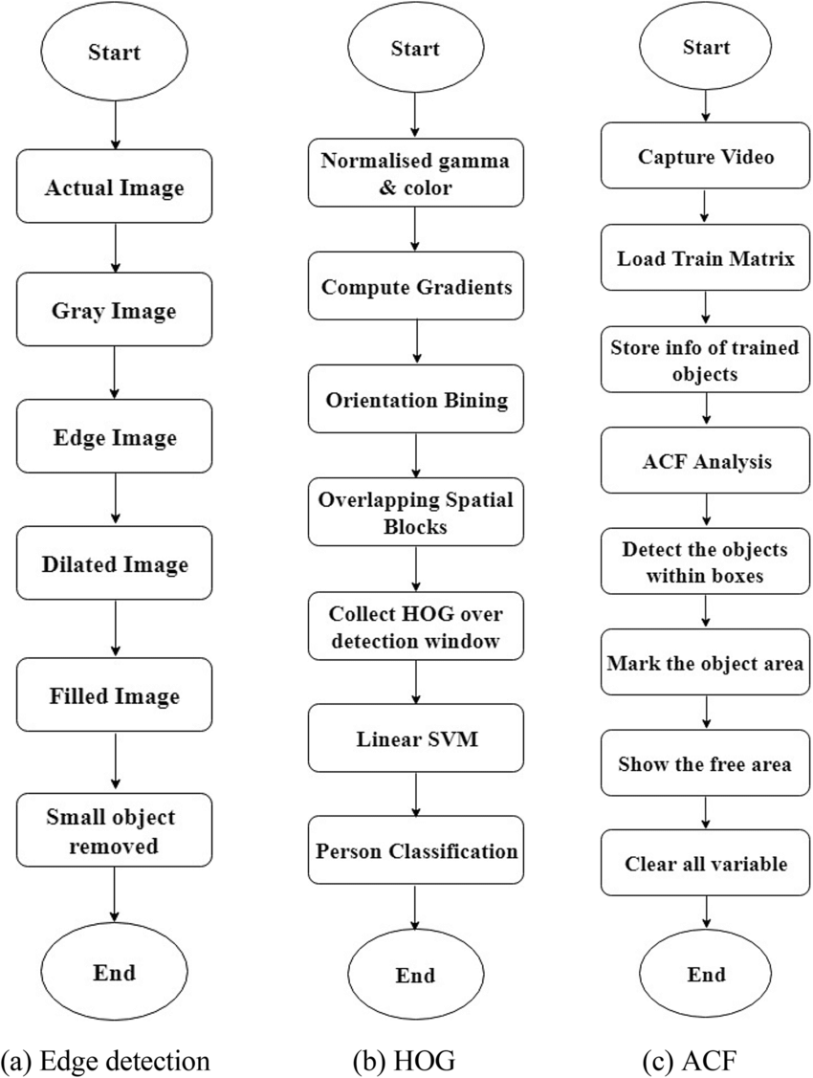

Figure 63-Different techniques of image processing.

1. WSN Approach Wireless Sensor Networks (WSNs) play a crucial role in fire detection by forming a distributed network of interconnected sensors designed to monitor environmental conditions. In the context of fire detection, these sensors are strategically deployed across an area of interest and equipped with the capability to sense various parameters associated with fire, such as temperature, smoke, and heat. The sensors continuously collect data and communicate wirelessly with each other to form a comprehensive network. In the event of a fire, anomalies in the sensed data, such as a rapid increase in temperature or the presence of smoke particles, trigger alerts within the WSN.

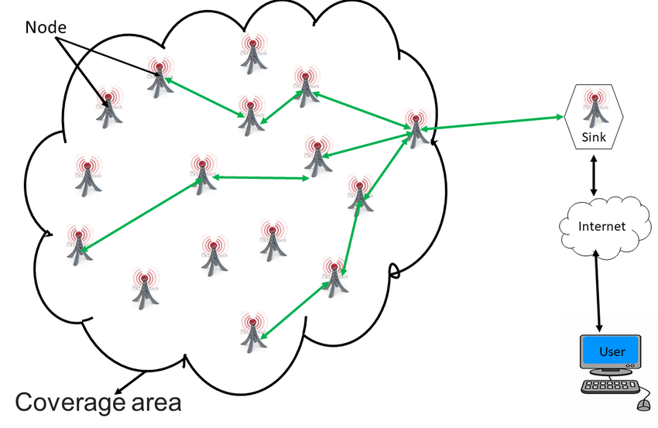

*Figure 8- General architecture of a wireless sensor network (WSN)*

1. Machine learning using neural networks: Machine learning is a powerful tool in fire detection, leveraging algorithms to automatically recognize patterns and anomalies associated with fire events. In the context of fire detection, ML models are trained on datasets containing images, video feeds, or sensor data capturing diverse scenarios of fires and non-fire environments. These models learn to distinguish between normal environmental conditions and the unique visual or data signatures indicative of a fire. For image-based fire detection, convolutional neural networks (CNNs) are commonly employed to extract features, while for sensor data, algorithms like decision trees or support vector machines may be utilized. The trained ML models can then autonomously analyze new data in real-time, swiftly identifying the presence of a fire and triggering timely responses.

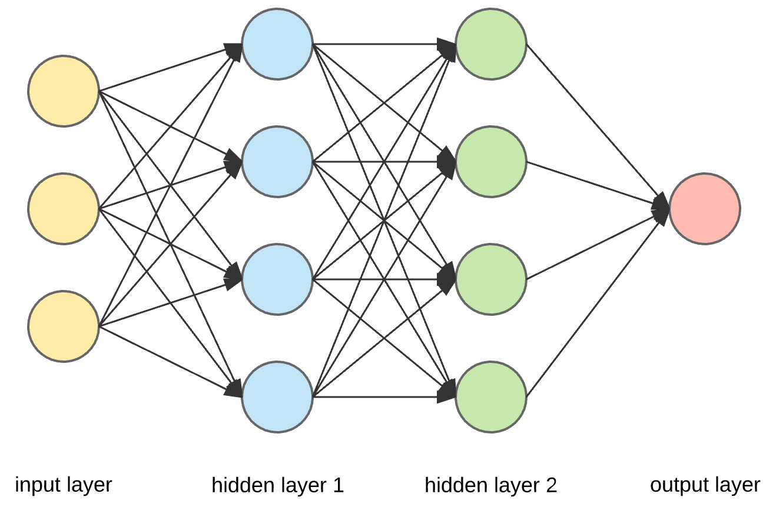

*Figure 9- image classification with convolutional neural networks*

## Appendix C: Components:

1. Raspberry Pi Camera : The Raspberry Pi Camera Module V2 is an official camera accessory designed for Raspberry Pi boards.

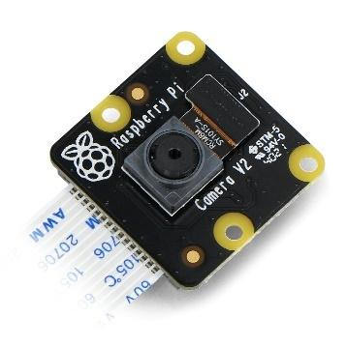

*Figure 19- camera -* [*https://botland.store/raspberry-pi-cameras/6128-raspberry-pi-noir-camera-hd-v2-8mpx-original-night-camera-for-raspberry-pi-652508442198.html*](https://botland.store/raspberry-pi-cameras/6128-raspberry-pi-noir-camera-hd-v2-8mpx-original-night-camera-for-raspberry-pi-652508442198.html)

1. Raspberry Pi Model 3 B 4GB Ram: It is a small single board computer. The Raspberry Pi is equipped with various components, including a processor, memory, input/output ports, and support for external peripherals. These boards run on open-source operating systems like Raspberry Pi OS.

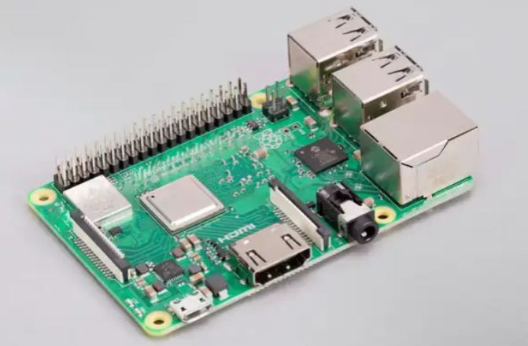

*Figure 20 - Raspberry Pi 3+ Model B -* [*https://bec-lb.com/products/raspberry-pi-4-model-b-4gb-ram?_pos=2&_sid=05497e42e&_ss=r*](https://bec-lb.com/products/raspberry-pi-4-model-b-4gb-ram?_pos=2&_sid=05497e42e&_ss=r)

1. Water Pump: It is used to transfer water from one location to the other. Speed induces pressure in electric water pumps. We used a fuel/water pump that works on 12V which we found suitable for our setup.

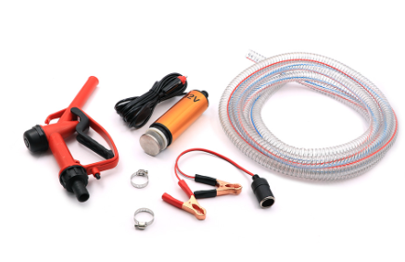

Figure 64 - Water pump.

1. MG995 Servo: MG995 is a standard-sized servo motor commonly used in robotics projects, and various applications that require precise control of angular motion.

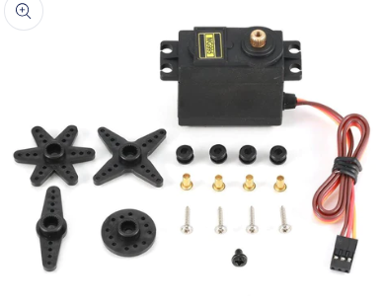

*Figure 22- MG995 servo -https://bec-lb.com/products/servo-mg995-12kg?_pos=1&_sid=72a2bfa1e&_ss=r*

1. MQ-2 Smoke Gas Sensor: The MQ-2 is a gas sensor module that is commonly used to detect various gases in the air. It is particularly known for its capability to detect smoke and flammable gases.

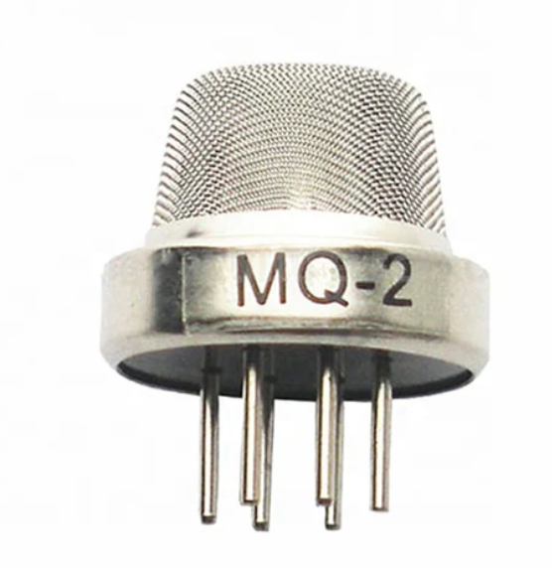

*Figure 17- MQ2 Sensor -* [*https://electroslab.com/products/mq-2-smoke-gas-sensor-module?_pos=1&_psq=smoke&_ss=e&_v=1.0*](https://electroslab.com/products/mq-2-smoke-gas-sensor-module?_pos=1&_psq=smoke&_ss=e&_v=1.0)

We tested the MQ2 Sensor on Arduino Uno, which takes 10-bit analog input, so the smoke value ranges from 0-1024, an on the NodeMCU-32-S which takes 12 bit.

1. AMG8833 Thermal Imager:

AMG8833 is an 8x8 thermal infrared sensor array capable of detecting human presence and measuring temperatures from 0 to 80 degrees Celsius. It's widely used in applications such as thermal cameras, motion detection, and environment monitoring due to its high accuracy and ease of integration with microcontrollers.

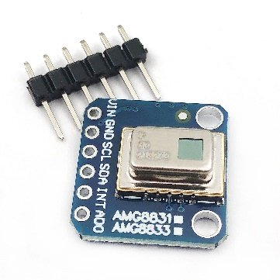

Figure 65- AMG8833- https://www.amazon.com/DEVMO-AMG8833-Temperature-Compatible-Rasp-Berry/dp/B09L4QP91N

We tested the thermal imager on Arduino and NodeMCU-32S, it is capable of generating an 8x8 array of heat as seen below. Please check the appendix for the code. We also generated a heatmap for ease of use.

1. NodeMCU-32S:The NodeMCU-32S is a development board based on the ESP32 microcontroller, which is a powerful and versatile system-on-chip (SoC) designed by Espressif. The ESP32 offers a wide range of features suitable for various IoT applications, including a dual-core Processor, Wi-Fi and Bluetooth, GPIOs, integrated peripherals, power management, development support, built-in Flash Memory and a micro-USB Port.

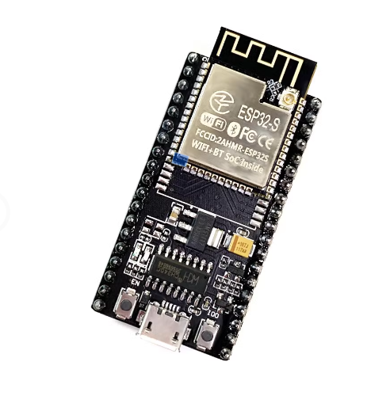

Figure 66- ESP32-NodeMCU-32S- \https://www.ubuy.com.lb/en/productcn/IEN3XPJLC-nodemcu-esp-32s-esp-wroom-32e-wifi-development-board-service-port-wifi-bluetooth-module-

1. Arduino Relay:

A relay module allows a microcontroller to control high voltage devices that operate on DC or AC power. This one requires 5 volts, and it is capable of switching up to 10 Amps.

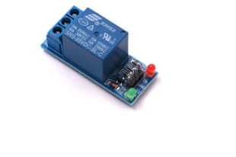

Figure 67 - Arduino relay module-https://katranji.com/en/item/365048.

## Appendix D: Codes:

### Smoke Senor Testing:

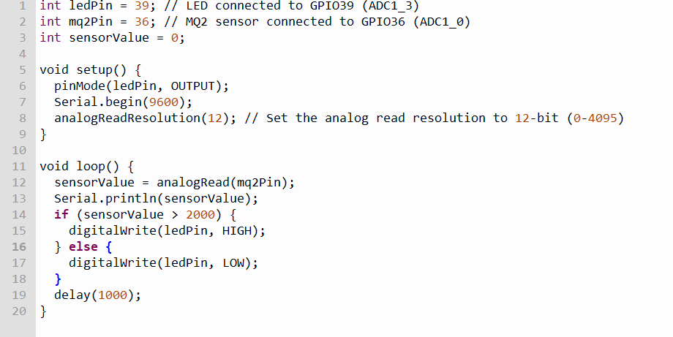

Figure 68-Smoke Sensor Testing on ESP32.

### Thermal Imager Code:

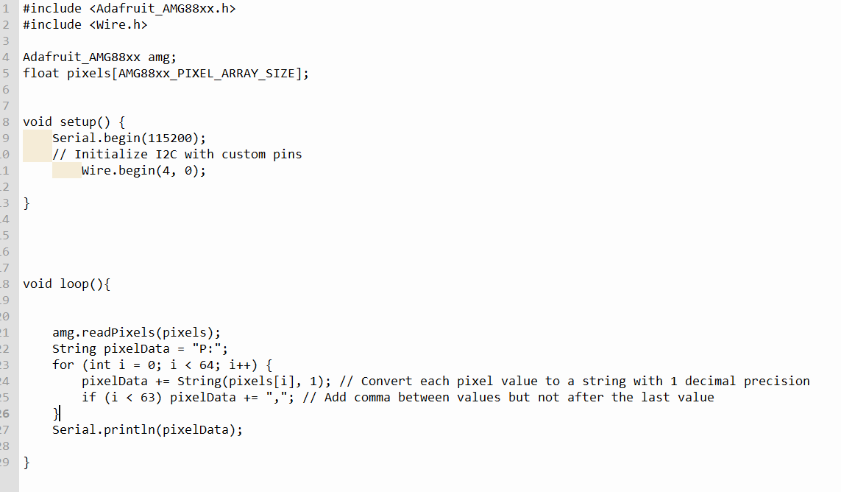

Figure 69- Thermal imager code.

### Heatmap code using python:

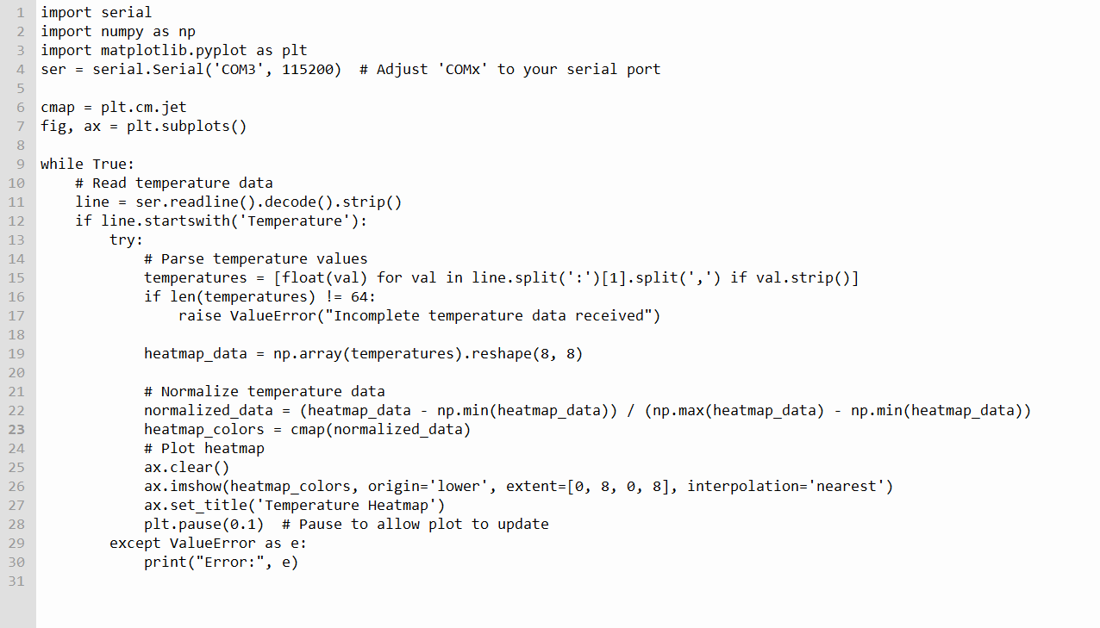

Figure 70 - heatmap code.

### YoloV5 Detect.py on Raspberry Pi:

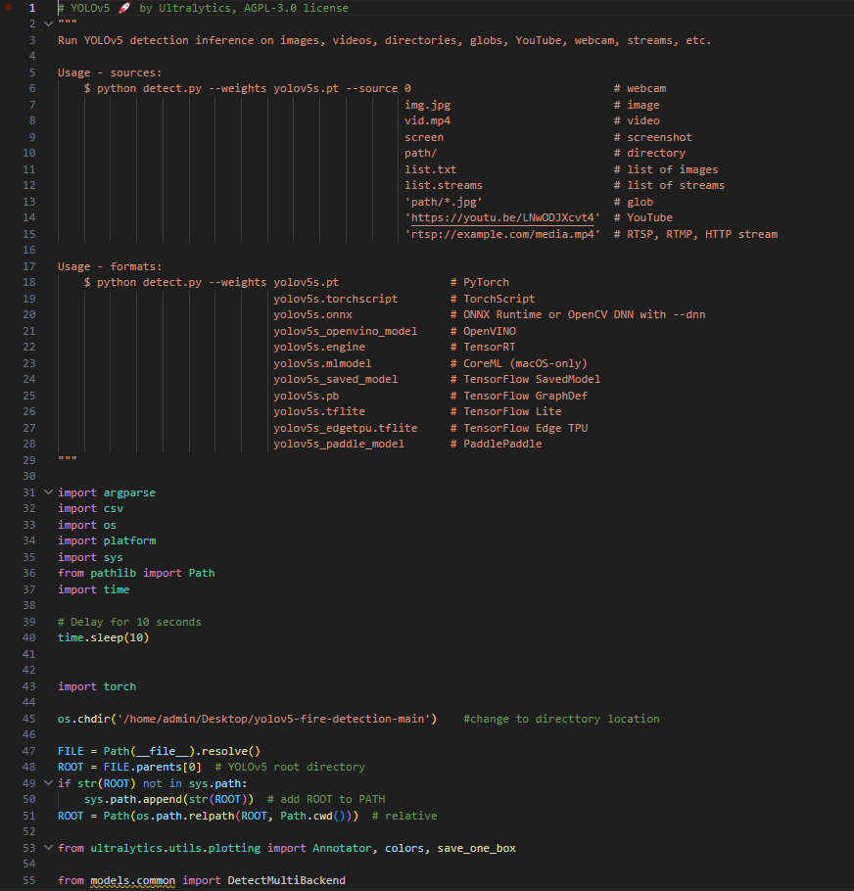

Figure 71 - detecy.py pt1.

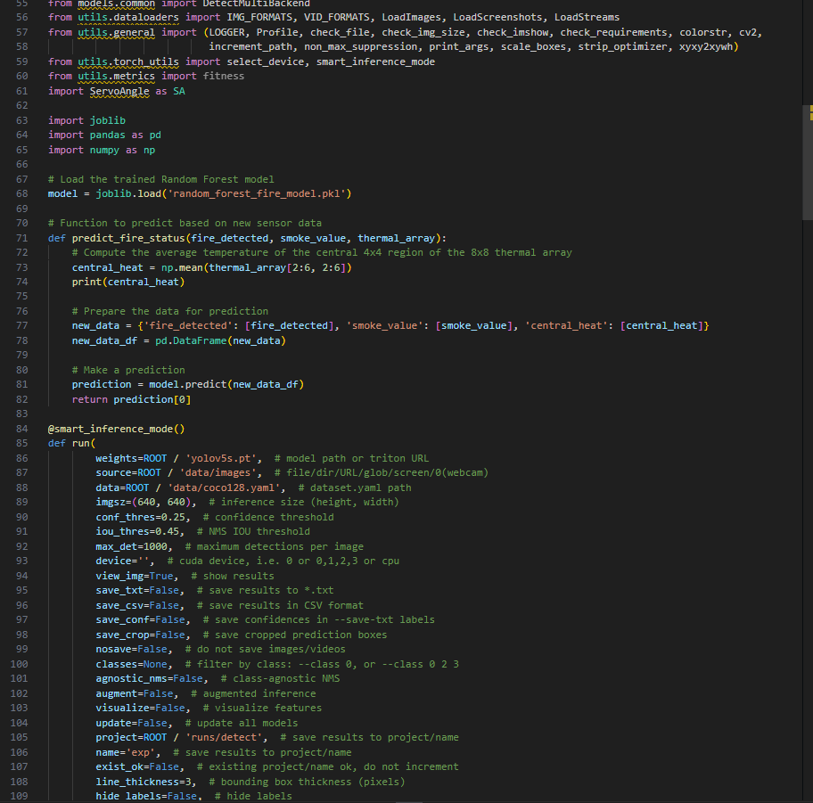

Figure 72- detect.py pt2

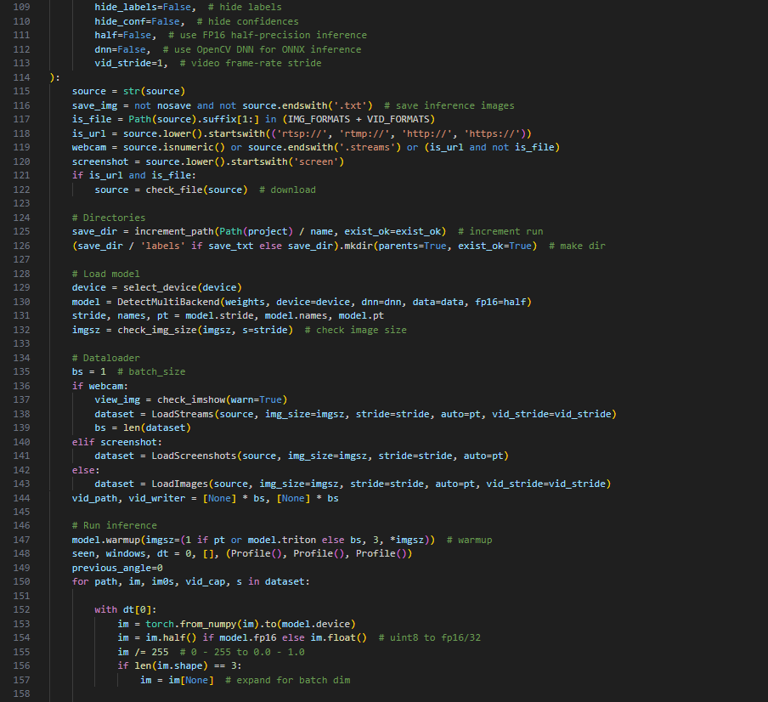

Figure 73- detect.py pt3.

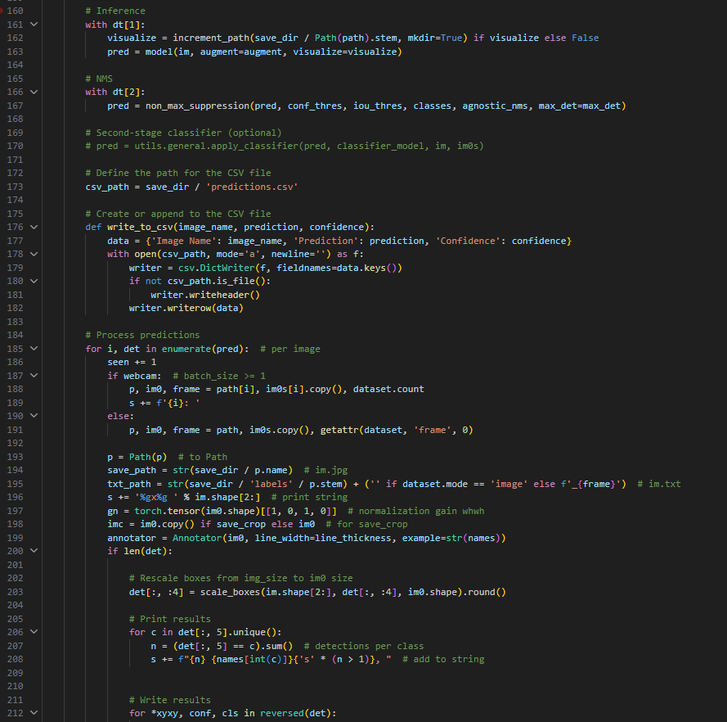

Figure 74 - detet.py pt4

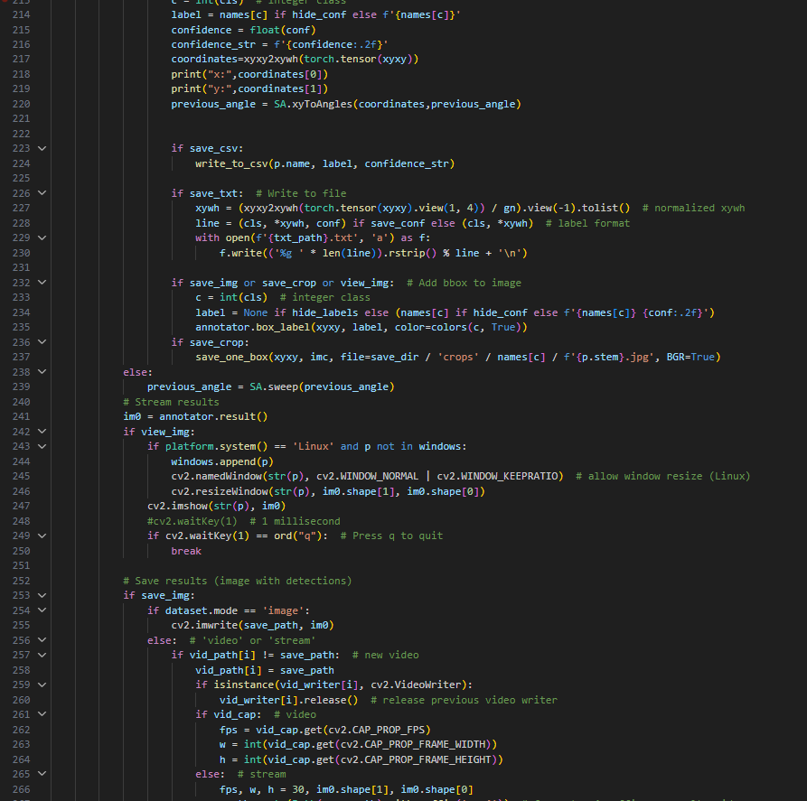

Figure 75- detect.py pt5.

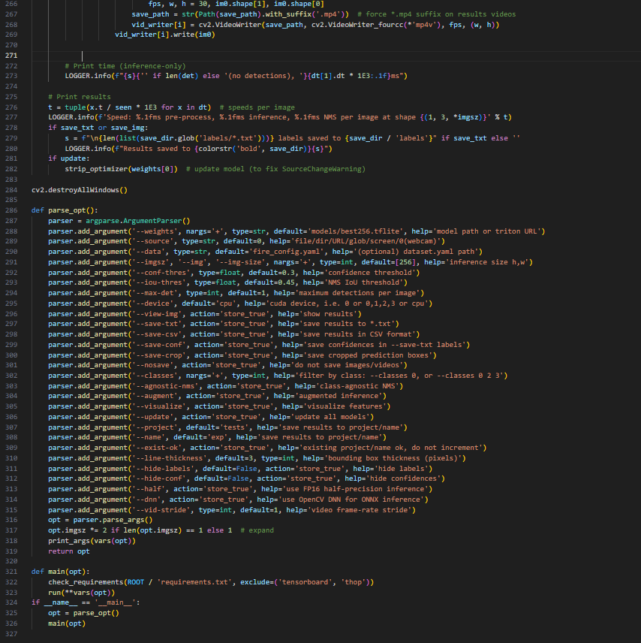

Figure 76 - detect.py pt 6.

### Coordinates:

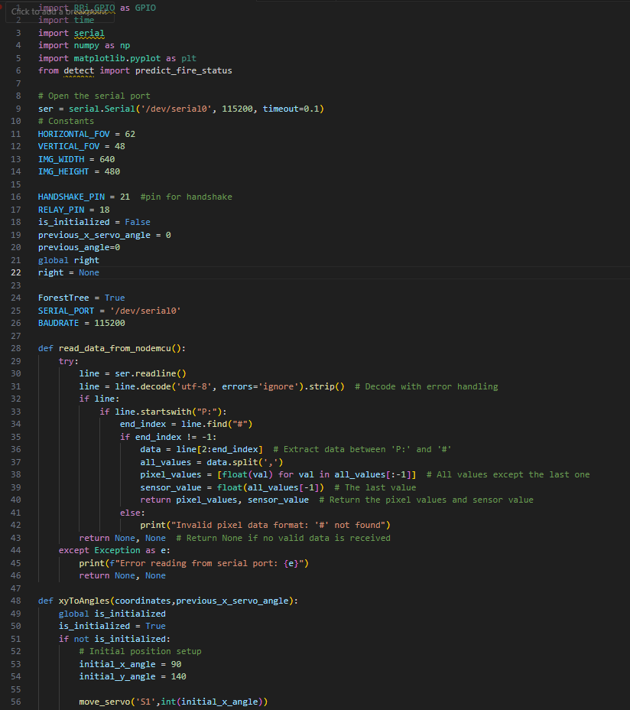

Figure 77 - SAtoAngles.py pt1.

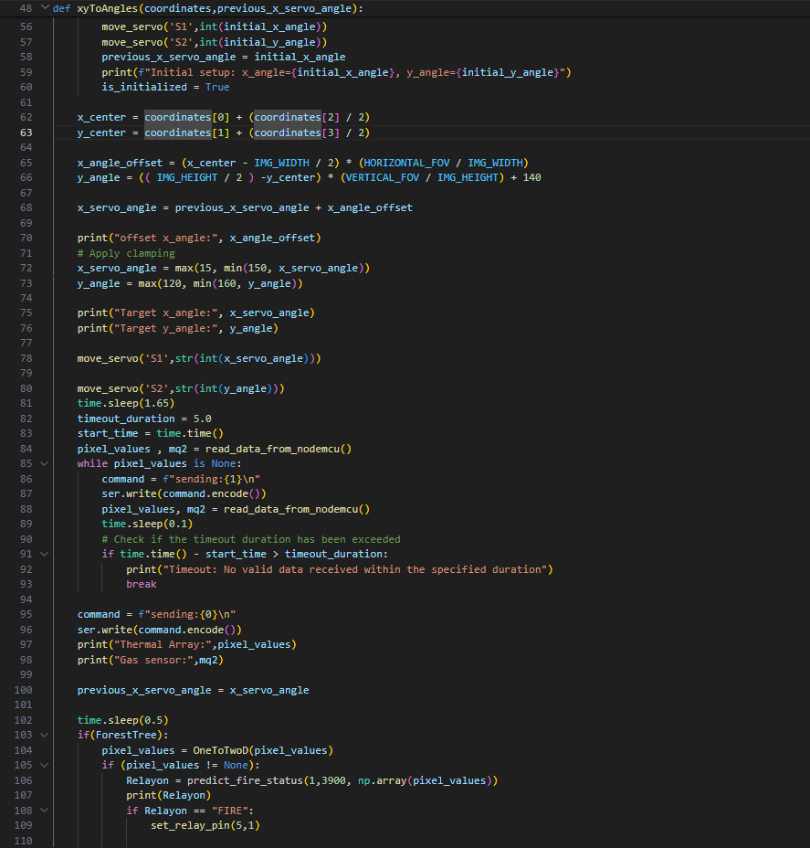

Figure 78- - SAtoAngles.py pt2.

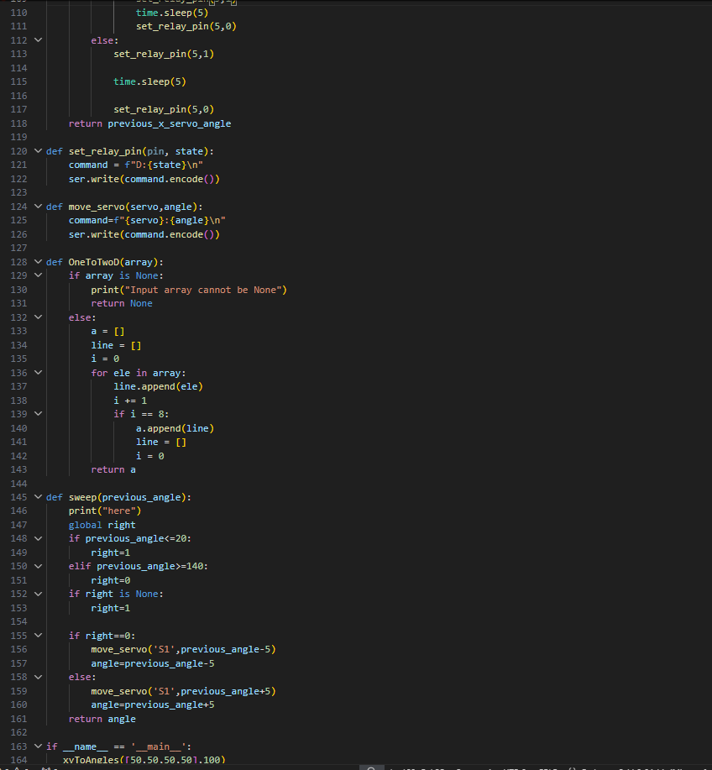

Figure 79 - SAtoAngles.py pt3.

### Run on Start:



Figure 80 - Run model when RPI starts.

### Broadcast CamToWeB:

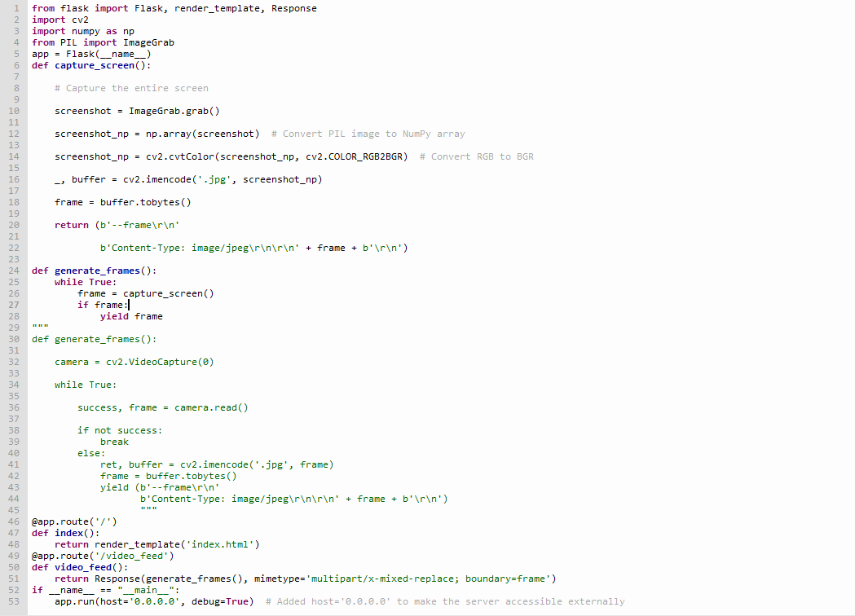

Figure 81 - Broadcast Cam to Webpage.

### NodeMCU32-S Initialization Code:

#include <EEPROM.h>

#include <ESP32Servo.h>

#include <WiFi.h>

#include <ESPmDNS.h>

#include <WiFiClient.h>

#include <WebServer.h>

#include <Wire.h>

#include <Adafruit_AMG88xx.h>

// Create the AMG88xx object

Adafruit_AMG88xx amg;

// Define the array to store temperature values

float pixels[AMG88xx_PIXEL_ARRAY_SIZE];

Servo servo1;  // create servo object to control the first servo

Servo servo2;  // create servo object to control the second servo

int servoPin1 = 18;    // pin for servo 1

int servoPin2 = 17;    // pin for servo 2

int digitalPin = 5;    // digital pin for control

int buttonPin = 19;    // pin for the push button

int lastPos1 = -1; // Store the last position of servo1

int lastPos2 = -1; // Store the last position of servo2

WebServer server(80);

int send;

bool automaticMode = true;

int automaticPosition1 = 90;  // Default position for servo 1 in automatic mode

int automaticPosition2 = 90;  // Default position for servo 2 in automatic mode

bool isInitialized = false;   // Initialization flag

unsigned long buttonPressTime = 0;

bool buttonPressed = false;

// EEPROM addresses

#define INIT_FLAG_ADDR 16

#define SSID_ADDR 17

#define PASSWORD_ADDR 49

#define EEPROM_SIZE 81 // Total EEPROM size

#define MQ2_PIN 36  // Define the pin where the sensor is connected

void createAccessPoint();

void saveCredentials(String ssid, String password);

void connectToWiFi();

void handleRoot();

void handleControl();

void handleAutomatic();

void handleTurnOnRelay();

void handleTurnOffRelay();

void resetEEPROM();

bool s = true;

void setup() {

  Serial.begin(115200);

  send=1;

  ESP32PWM::allocateTimer(0);

  ESP32PWM::allocateTimer(1);

  ESP32PWM::allocateTimer(2);

  ESP32PWM::allocateTimer(3);

  delay(2000);

  Serial.println("Starting setup...");

  // Read the initialization flag

  EEPROM.begin(EEPROM_SIZE);

  isInitialized = EEPROM.read(INIT_FLAG_ADDR) == 1;

  Serial.println(isInitialized ? "Already Initialized" : "Not Initialized");

  if (!isInitialized) {

      createAccessPoint();

  } else {

      connectToWiFi();

  }

  // Initialize servo motors

  servo1.setPeriodHertz(50);

  servo1.attach(servoPin1, 600, 2400);

  servo2.setPeriodHertz(50);

  servo2.attach(servoPin2, 600, 2400);

  // Initialize digital pin

  pinMode(digitalPin, OUTPUT);

  // Initialize button pin

  pinMode(buttonPin, INPUT_PULLUP);

  pinMode(MQ2_PIN, INPUT);  // Set the MQ-2 pin as input

  // Initialize I2C with custom pins

  Wire.begin(4, 0); // SDA on GPIO 4 (D2), SCL on GPIO 0 (D3)

  // Initialize AMG88xx sensor

  if (!amg.begin()) {

      Serial.println("Could not find a valid AMG88xx sensor, check wiring!");

      while (1);

  }

  // Set up routes for web server

  server.on("/", HTTP_GET, handleRoot);

  server.on("/control", HTTP_POST, handleControl);

  server.on("/automatic", HTTP_POST, handleAutomatic);

  server.on("/turnOnRelay", HTTP_POST, handleTurnOnRelay);

  server.on("/turnOffRelay", HTTP_POST, handleTurnOffRelay);

  server.on("/resetEEPROM", HTTP_POST, [](){

      resetEEPROM();

  });

  // Start the server

  server.begin();

  Serial.println("HTTP server started");

  EEPROM.end();

}

void loop() {

  server.handleClient();

  // Read pixels

  amg.readPixels(pixels);

  // Serialize pixel data

  String pixelData = "P:";

  for (int i = 0; i < 64; i++) { // assuming there are 64 pixels

      pixelData += String(pixels[i], 1); // Convert each pixel value to a string with 1 decimal precision

      if (i < 63) pixelData += ","; // Add comma between values but not after the last value

  }

  int sensorValue = analogRead(MQ2_PIN);  // Read the analog value from the sensor

  pixelData += ",";

  pixelData += String(sensorValue);

  pixelData += "#";

  // Button press detection for EEPROM reset

  if (digitalRead(buttonPin) == LOW) {

      if (!buttonPressed) {

          buttonPressed = true;

          buttonPressTime = millis();

          Serial.println("reset");

      } else {

          if (millis() - buttonPressTime >= 5000) {

              Serial.println("Starting reset...");

              resetEEPROM();

              ESP.restart(); // Restart the ESP32

          }

      }

  } else {

      buttonPressed = false;

  }

  if (automaticMode) {

      static bool firstRun = true;

      if (firstRun) {

          Serial.println("Automatic Mode Active");

          firstRun = false;

      }

      if (Serial.available() > 0) {

          String data = Serial.readStringUntil('\n');

          if (data.startsWith("S1:")) {

              int pos1 = data.substring(3).toInt();

              if (abs(lastPos1 - pos1) > 2) { // Only update if position change is significant

                  lastPos1 = pos1;

                  servo1.write(pos1);

                  Serial.println("Moved Servo 1 to position: " + String(pos1));

              }

          } else if (data.startsWith("S2:")) {

              int pos2 = data.substring(3).toInt();

              delay(1000);

              Serial.println(send);

              if(s){

                  if(send == 1){

                    String sending = Serial.readStringUntil('\n');

                    int send = sending.substring(8).toInt();

                     Serial.println(send);

                     if (send == 0){

                      s=false;

                     }

                     else{

                      s=true;

                     }

                    Serial.println(pixelData);

                  };

              }

              if (abs(lastPos2 - pos2) > 2) { // Only update if position change is significant

                  lastPos2 = pos2;

                  servo2.write(pos2);

                  Serial.println("Moved Servo 2 to position: " + String(pos2));

              }

          } else if (data.startsWith("D:")) {

              int state = data.substring(2).toInt();

              digitalWrite(digitalPin, state);

              Serial.println("Set digital pin to state: " + String(state));

          }

      }

  }

}

void createAccessPoint() {

    Serial.println("NodeMCU is not initialized. Starting AP mode...");

    WiFi.softAP("NodeMCU Setup");

    IPAddress apIP = WiFi.softAPIP();

    Serial.print("AP IP address: ");

    Serial.println(apIP);

    server.on("/", HTTP_GET, []() {

    String html = "<html><head><style>";

    html += "body { font-family: Arial, sans-serif; text-align: center; padding: 20px; }";

    html += "h1 { color: #333; }";

    html += "label { display: block; margin: 10px 0 5px; }";

    html += "input { padding: 8px; margin-bottom: 10px; width: 80%; max-width: 300px; }";

    html += "button { padding: 10px 20px; font-size: 16px; margin-top: 10px; }";

    html += "form { display: inline-block; text-align: left; }";

    html += "</style></head><body>";

    html += "<h1>Welcome to NodeMCU Setup</h1>";

    html += "<form action='/setup' method='post'>";

    html += "<label>WiFi SSID:</label><input type='text' name='ssid'><br>";

    html += "<label>Password:</label><input type='password' name='password'><br>";

    html += "<button type='submit'>Save</button>";

    html += "</form></body></html>";

    server.send(200, "text/html", html);

});

    server.on("/setup", HTTP_POST, []() {

        String ssid = server.arg("ssid");

        String password = server.arg("password");

        saveCredentials(ssid, password);

        Serial.println("Credentials saved: " + ssid + " " + password);

        EEPROM.begin(EEPROM_SIZE);

        EEPROM.write(INIT_FLAG_ADDR, 1);

        EEPROM.commit();

        EEPROM.end();

        server.send(200, "text/html", "<html><body><h1>Setup completed. restarting the NodeMCU.</h1></body></html>");

        delay(500);

        ESP.restart();

    });

    server.begin();

}

void connectToWiFi() {

    Serial.println("Connecting to WiFi...");

    EEPROM.begin(EEPROM_SIZE);

    String ssid = "";

    String password = "";

    char c;

    for (int i = SSID_ADDR; i < PASSWORD_ADDR; ++i) {

        c = EEPROM.read(i);

        if (c == 0) break;

        ssid += c;

    }

    for (int i = PASSWORD_ADDR; i < EEPROM_SIZE; ++i) {

        c = EEPROM.read(i);

        if (c == 0) break;

        password += c;

    }

    EEPROM.end();

    Serial.print("Stored SSID: ");

    Serial.println(ssid);

    Serial.print("Stored Password: ");

    Serial.println(password);

    WiFi.begin(ssid.c_str(), password.c_str());

    int maxAttempts = 30;

    while (WiFi.status() != WL_CONNECTED && maxAttempts-- > 0) {

        delay(1000);

        Serial.print(".");

    }

    if (WiFi.status() == WL_CONNECTED) {

        Serial.println("\nConnected to WiFi");

        Serial.print("ESP32 IP Address: ");

        Serial.println(WiFi.localIP());

    } else {

        Serial.println("\nFailed to connect. Please check the credentials and signal strength.");

    }

}

void saveCredentials(String ssid, String password) {

    EEPROM.begin(EEPROM_SIZE);

    for (int i = SSID_ADDR; i < PASSWORD_ADDR + 32; ++i) {

        EEPROM.write(i, 0);

    }

    for (int i = 0; i < ssid.length() && (SSID_ADDR + i) < PASSWORD_ADDR; ++i) {

        EEPROM.write(SSID_ADDR + i, ssid[i]);

    }

    for (int i = 0; i < password.length() && (PASSWORD_ADDR + i) < EEPROM_SIZE; ++i) {

        EEPROM.write(PASSWORD_ADDR + i, password[i]);

    }

    EEPROM.commit();

    EEPROM.end();

    delay(1000);

    EEPROM.begin(EEPROM_SIZE);

    Serial.print("Stored SSID: ");

    String readSSID = "";

    for (int i = SSID_ADDR; i < PASSWORD_ADDR; ++i) {

        char c = EEPROM.read(i);

        if (c != 0) readSSID += c;

    }

    Serial.println(readSSID);

    Serial.print("Stored Password: ");

    String readPassword = "";

    for (int i = PASSWORD_ADDR; i < EEPROM_SIZE; ++i) {

        char c = EEPROM.read(i);

        if (c != 0) readPassword += c;

    }

    Serial.println(readPassword);

    EEPROM.end();

}

void resetEEPROM() {

    EEPROM.begin(EEPROM_SIZE);

    for (int i = 0; i < EEPROM_SIZE; ++i) {

        EEPROM.write(i, 0); // Set each byte to 0

    }

    EEPROM.commit(); // Ensure the changes are saved to EEPROM

    EEPROM.end();

    Serial.println("EEPROM has been reset.");

}

void handleRoot() {

    String html = "<html><head><style>";

    html += "body { font-family: Arial, sans-serif; text-align: center; padding: 20px; }";

    html += "h1 { color: #333; }";

    html += "button { margin: 10px; padding: 10px 20px; font-size: 16px; }";

    html += "input[type=range] { width: 300px; }";

    html += "form { display: inline-block; margin: 20px 0; }";

    html += "</style></head><body><h1>System Monitor</h1>";

    html += "<h1>Live Webcam Stream</h1>";

    html += "<img id=\"videoStream\" src=\"http://192.168.1.102:5000/video_feed\" width=\"1280\" height=\"720\" alt=\"Live Stream\">";

    html += "<h1>Motor Control</h1>";

    // Servo 1 controls

    html += "<br><p>Servo 1: <span id='pos1'>90</span>°</p><button onclick='changeServo1(-10)'>-</button><input type='range' id='servo1' value='90' min='0' max='180' oninput='return false' style='pointer-events: none;'><button onclick='changeServo1(10)'>+</button><br>";

    // Servo 2 controls

    html += "<p>Servo 2: <span id='pos2'>90</span>°</p><button onclick='changeServo2(-10)'>-</button><input type='range' id='servo2' value='90' min='0' max='180' oninput='return false' style='pointer-events: none;'><button onclick='changeServo2(10)'>+</button><br>";

    // Relay controls

    html += "<button type='button' onclick='handleTurnOnRelay()'>Turn On Relay</button>";

    html += "<button type='button' onclick='handleTurnOffRelay()'>Turn Off Relay</button>";

    // Automatic mode checkbox

    html += "<form action='/automatic' method='post'>";

    html += "<label for='mode'>Mode:</label><input type='checkbox' id='mode' name='mode' value='automatic' onchange='updateMode(this)'checked><span id='modeStatus'>Automatic</span>";

    html += "</form>";

    // Reset EEPROM button

    html += "<button onclick='resetEEPROM()'>Reset EEPROM</button>";

    html += "</body><script>";

    // JavaScript functions to change servo angles

    html += "function changeServo1(delta) { updateServo(1, delta); }";

    html += "function changeServo2(delta) { updateServo(2, delta); }";

    html += "function updateServo(servo, delta) {";

    html += "var xhr = new XMLHttpRequest();";

    html += "xhr.open('POST', '/control', true);";

    html += "xhr.setRequestHeader('Content-type', 'application/x-www-form-urlencoded');";

    html += "var currentPos = parseInt(document.getElementById('servo' + servo).value) + delta;";

    html += "xhr.send('servo' + servo + '=' + currentPos);";

    html += "document.getElementById('servo' + servo).value = currentPos;";

    html += "document.getElementById('pos' + servo).innerHTML = currentPos;";

    html += "}";

    // JavaScript functions to handle the relay

    html += "function handleTurnOnRelay() {";

    html += "var xhr = new XMLHttpRequest();";

    html += "xhr.open('POST', '/turnOnRelay', true);";

    html += "xhr.setRequestHeader('Content-type', 'text/plain');";

    html += "xhr.onload = function() {";

    html += "if(xhr.status >= 200 && xhr.status < 300) {";

    html += "console.log('Relay turned on successfully:', xhr.responseText);";

    html += "} else {";

    html += "console.log('Failed to turn on relay');";

    html += "}";

    html += "};";

    html += "xhr.send();";

    html += "}";

    html += "function handleTurnOffRelay() {";

    html += "var xhr = new XMLHttpRequest();";

    html += "xhr.open('POST', '/turnOffRelay', true);";

    html += "xhr.setRequestHeader('Content-type', 'text/plain');";

    html += "xhr.onload = function() {";

    html += "if(xhr.status >= 200 && xhr.status < 300) {";

    html += "console.log('Relay turned off successfully:', xhr.responseText);";

    html += "} else {";

    html += "console.log('Failed to turn off relay');";

    html += "}";

    html += "};";

    html += "xhr.send();";

    html += "}";

    // JavaScript function for EEPROM reset

    html += "function resetEEPROM() {";

    html += "var xhr = new XMLHttpRequest();";

    html += "xhr.open('POST', '/resetEEPROM', true);";

    html += "xhr.send();";

    html += "}";

    html += "function updateMode(checkbox) {";

    html += "var xhr = new XMLHttpRequest();";

    html += "xhr.open('POST', '/automatic', true);";

    html += "xhr.setRequestHeader('Content-type', 'application/x-www-form-urlencoded');";

    html += "xhr.send('mode=' + (checkbox.checked ? 'automatic' : 'manual'));";

    html += "}";

    html += "</script></html>";

    server.send(200, "text/html", html);

}

void handleControl() {

    if (automaticMode) {

        // If automatic mode is active, don't execute servo control code

        server.send(200, "text/plain", "Automatic Mode Active");

        return;

    }

    if (server.hasArg("servo1")) {

        int pos1 = server.arg("servo1").toInt();

        servo1.write(pos1);

        Serial.println("Servo 1 moved to position: " + String(pos1));

    }

    if (server.hasArg("servo2")) {

        int pos2 = server.arg("servo2").toInt();

        servo2.write(pos2);

        Serial.println("Servo 2 moved to position: " + String(pos2));

    }

    server.send(200, "text/plain", "Action Completed");

}

void handleAutomatic() {

    if (server.hasArg("mode")) {

        if (server.arg("mode") == "automatic") {

            automaticMode = true;

            Serial.println("Switched to Automatic Mode");

        } else {

            automaticMode = false;

            Serial.println("Switched to Manual Mode");

        }

    }

    server.send(200, "text/html", "<html><body><h1>Mode Set</h1></body></html>");

}

void handleTurnOnRelay() {

    if (automaticMode) {

        // If automatic mode is active, don't execute relay control code

        server.send(200, "text/plain", "Automatic Mode Active");

        return;

    }

    // If not in automatic mode, execute relay control code

    digitalWrite(digitalPin, HIGH);

    Serial.println("Relay turned On.");

    server.send(200, "text/plain", "Relay turned on");

}

void handleTurnOffRelay() {

    if (automaticMode) {

        // If automatic mode is active, don't execute relay control code

        server.send(200, "text/plain", "Automatic Mode Active");

        return;

    }

    // If not in automatic mode, execute relay control code

    digitalWrite(digitalPin, LOW);

    Serial.println("Relay turned Off.");

    server.send(200, "text/plain", "Relay turned off");

}

### Forest Trees Dataset:

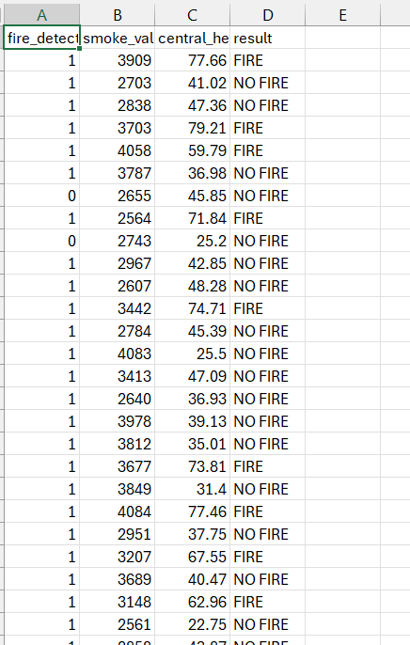

Figure 82- Forest Trees Dataset

### Forest Trees Model:

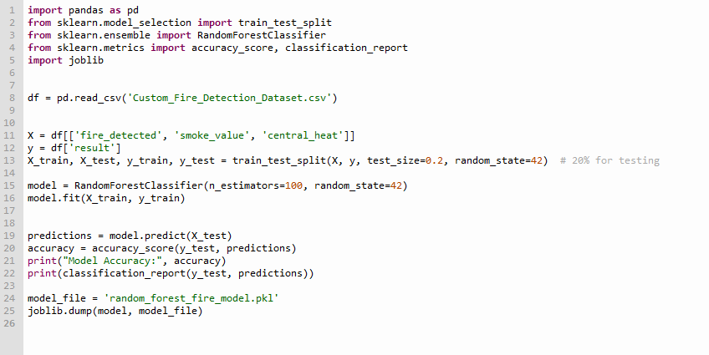

Figure 83- Model 2

## Appendix E: YoloV5 Testing:

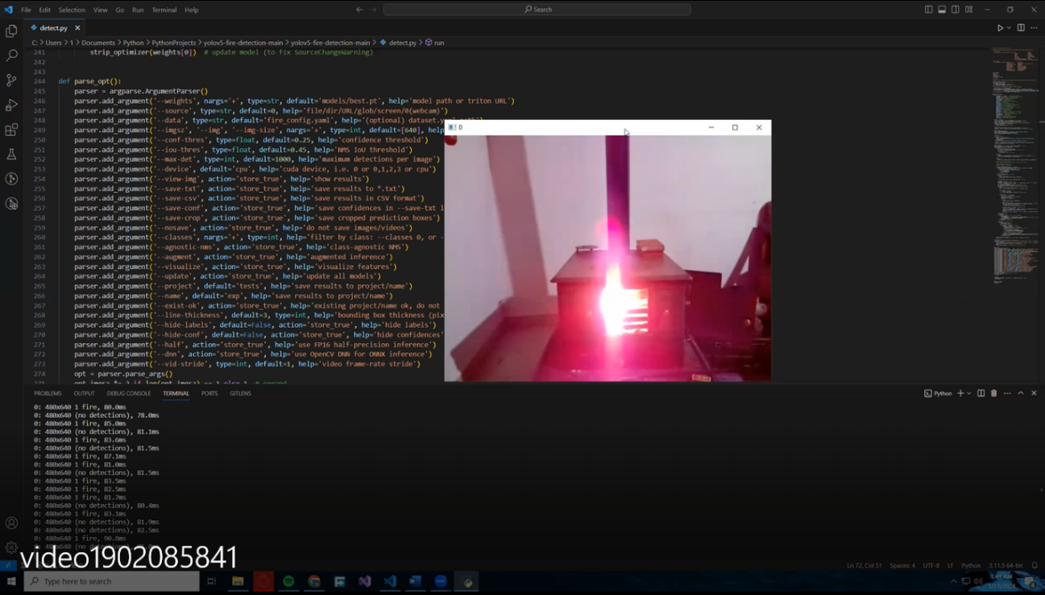

*Figure 23- Wood fire FN*

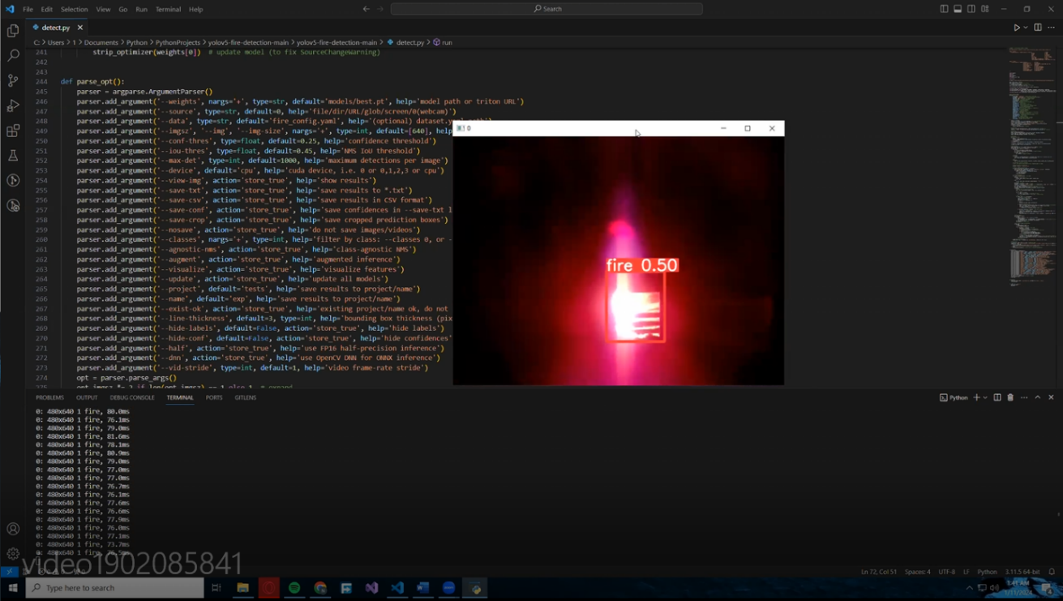

*Figure 24- Woof Fire TP*

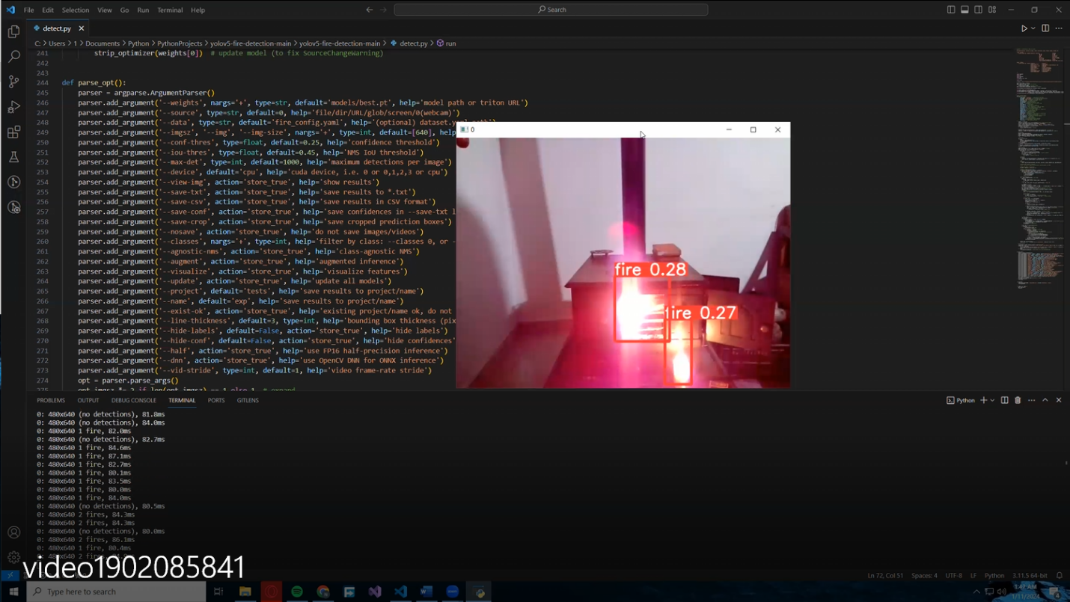

*Figure 25 - Wood and Candle TP*

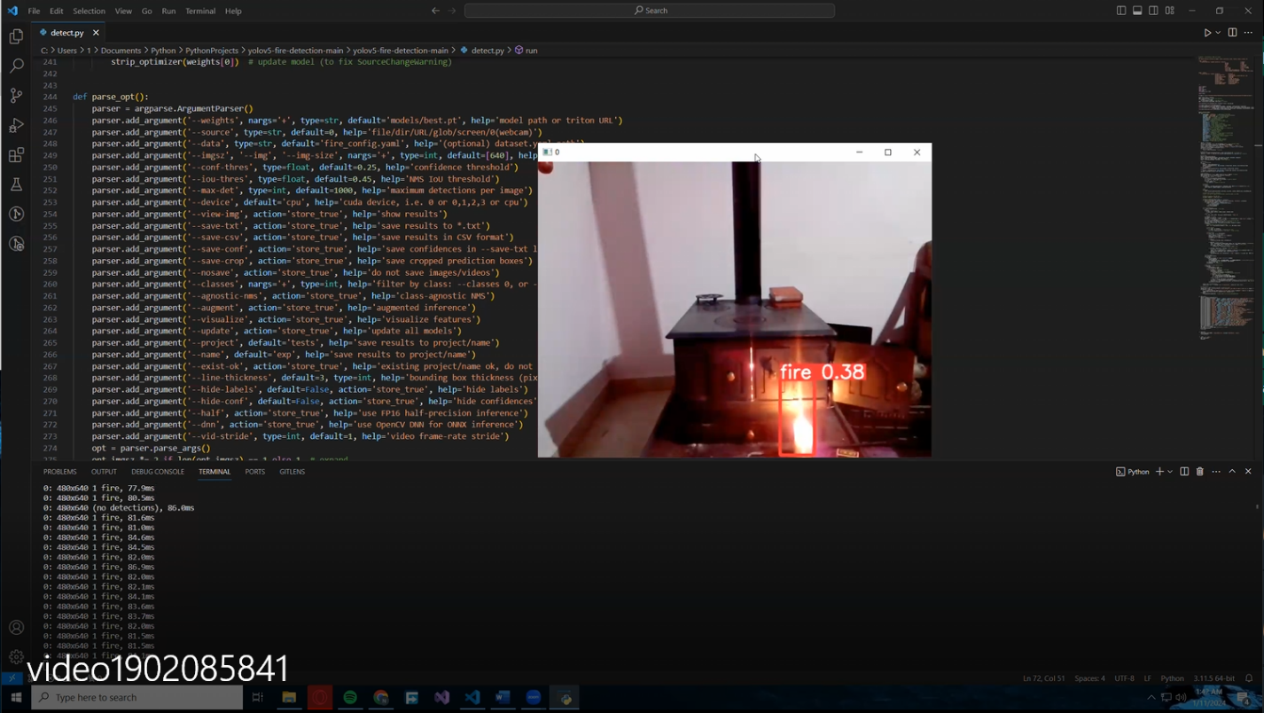

*Figure 26- Candle TP*

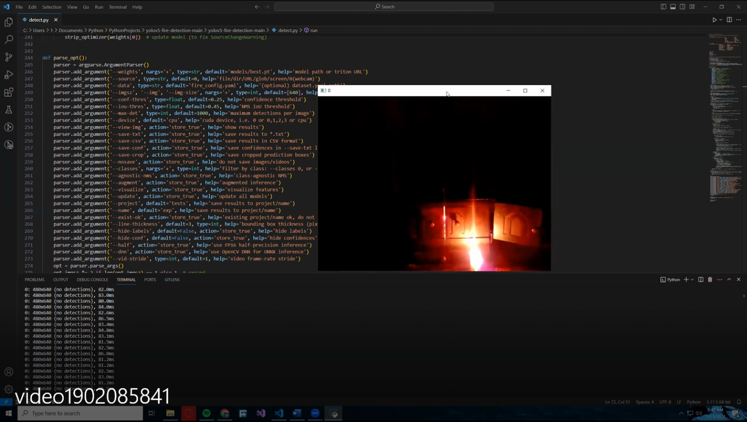

*Figure 27:CANDLE FN*

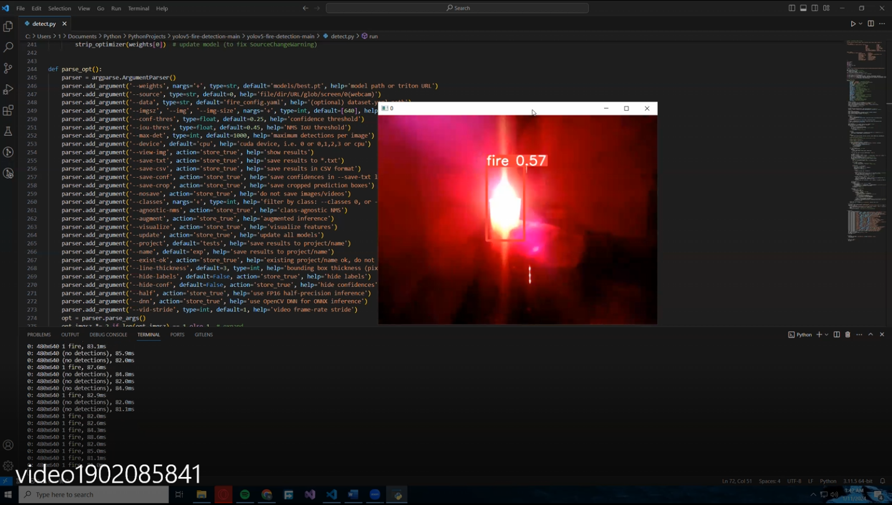

*Figure 28:CANDLE TP*

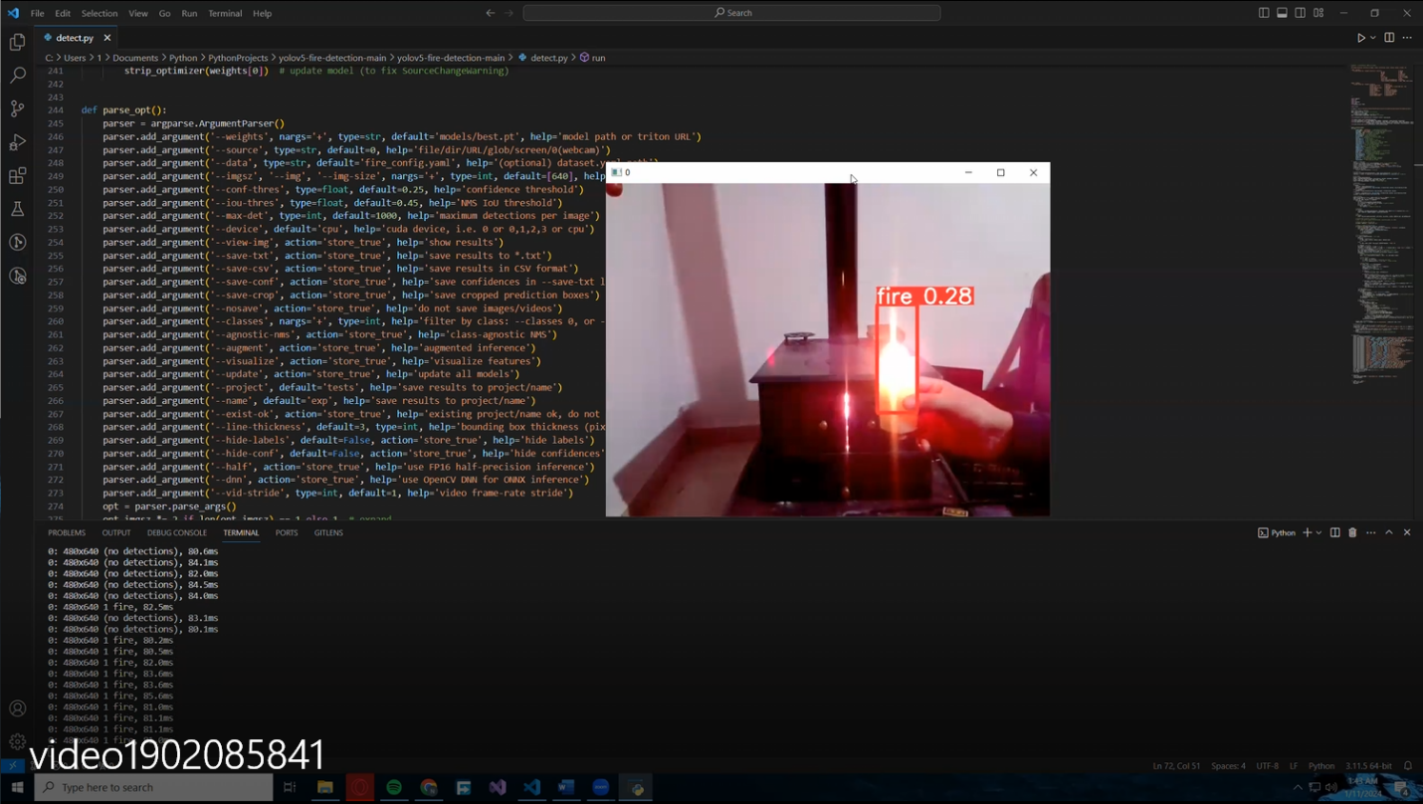

*Figure 29:CANDLE TP*

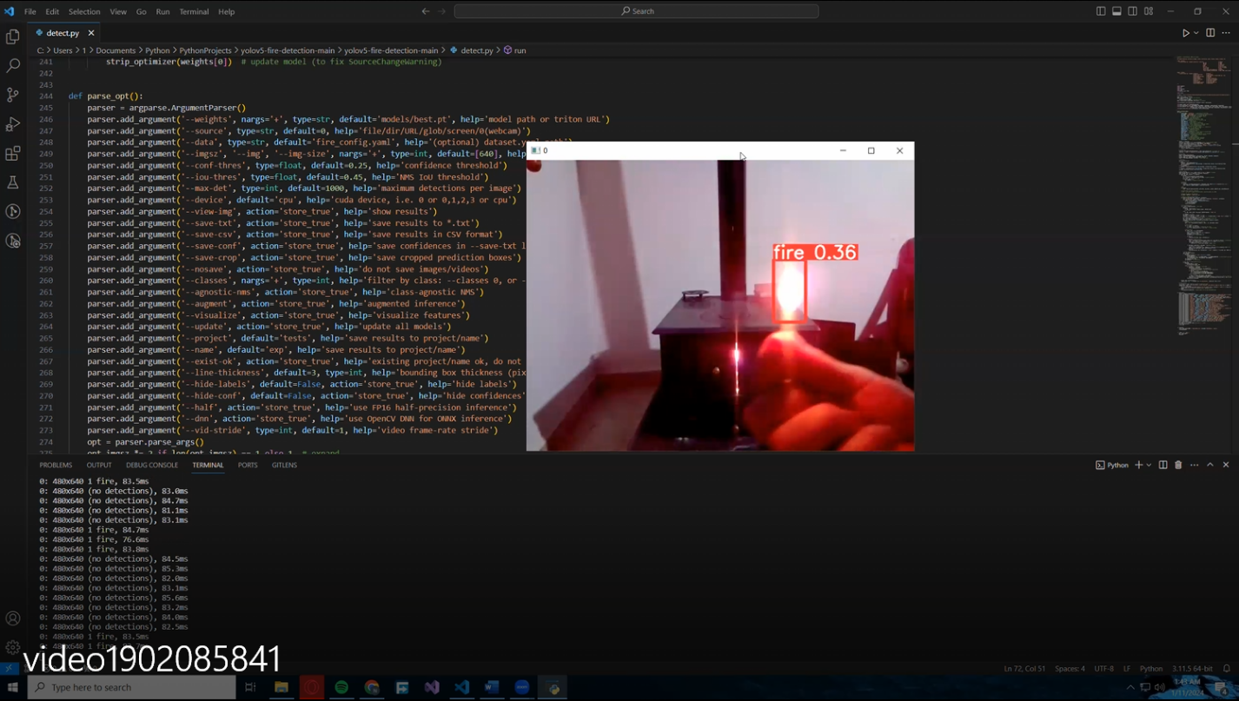

*Figure 30:MATCH TP*

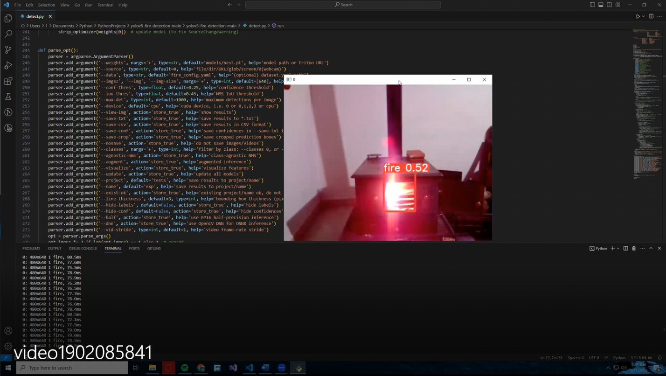

*Figure 31:WOOD TP*